Scheduling COVID-19 testing on the Patient Portal
Follow the instructions below to self-schedule an appointment for COVID-19 testing on the Patient Portal.
Access the portal directly at https://umassd.medicatconnect.com or by selecting this box
on the UMassD Health Services website https://www.umassd.edu/studentaffairs/health/

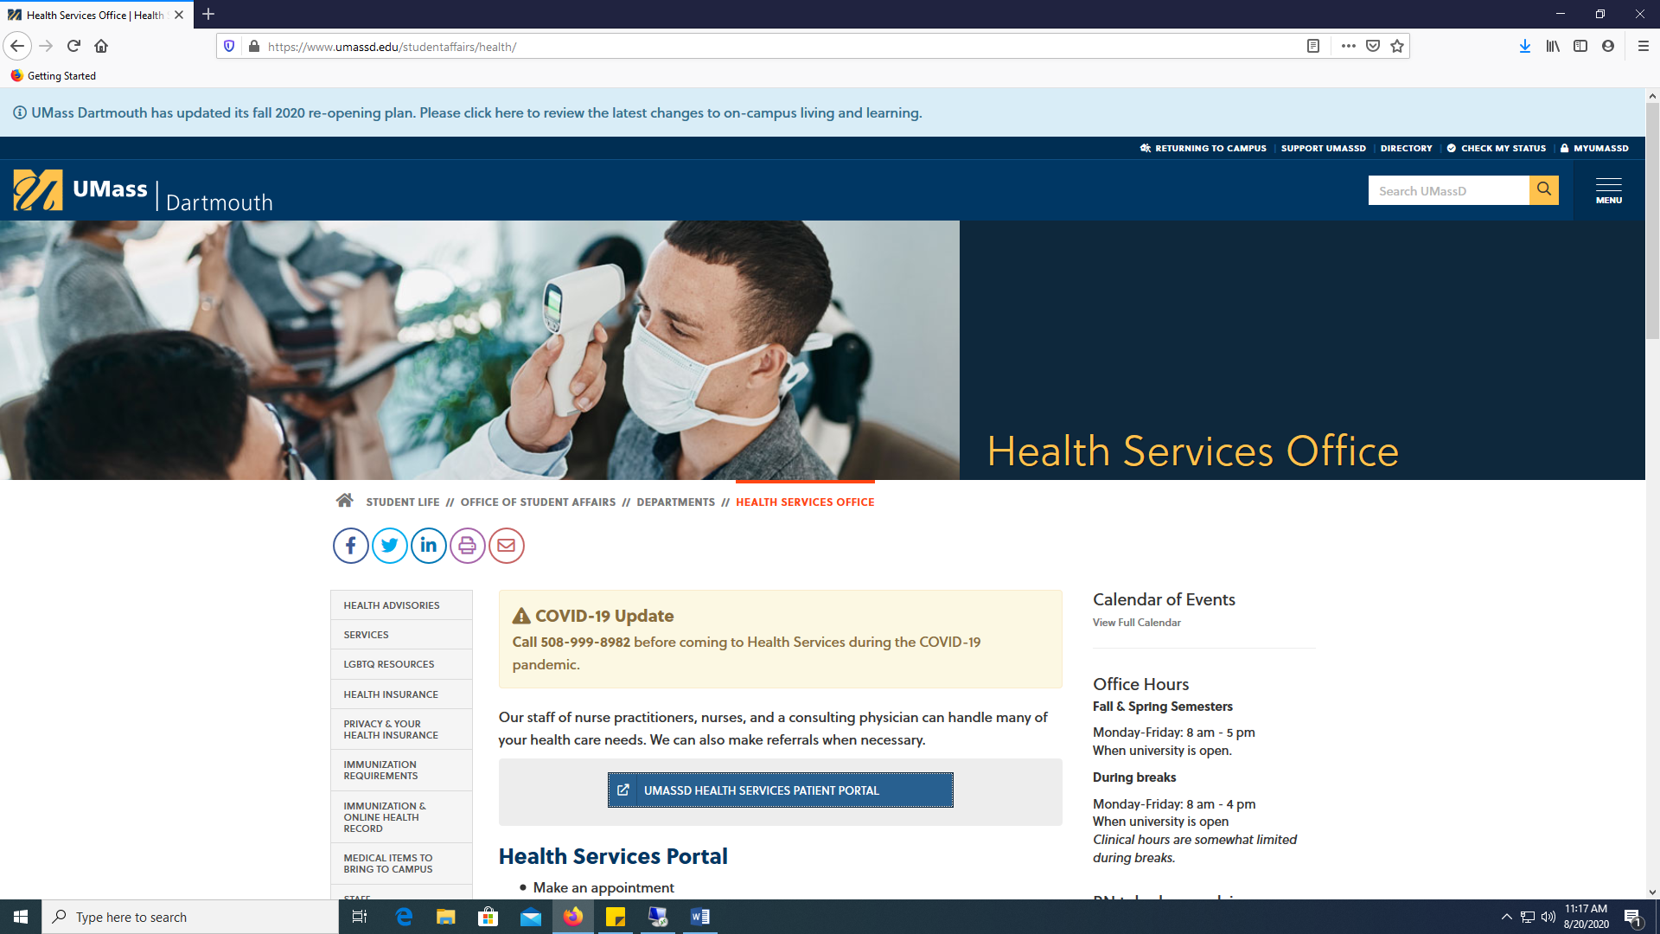

- Log into the Portal with your UMassD username and password.
- Select the Appointment Tab (highlighted here in yellow).
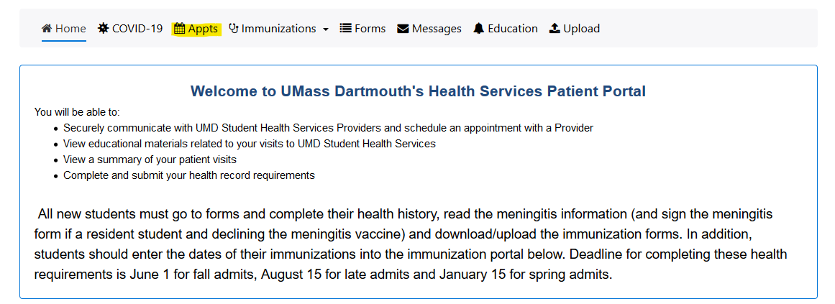

- The appointment screen will appear as:

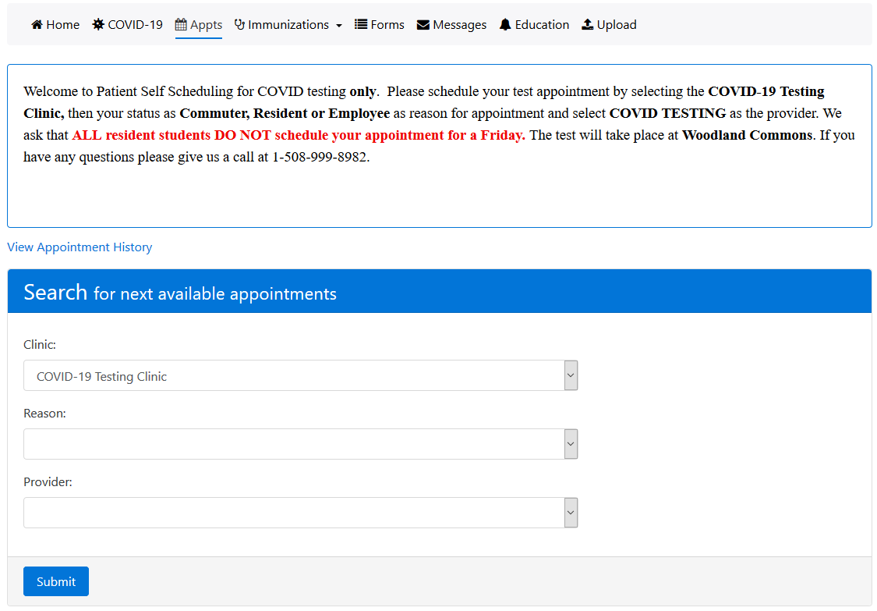

- Follow the instructions on screen to complete the questions and select Submit when done.
- Residential students are NOT to make appointments for a Friday.
- Select the Day and one of the available appointment’s in green.

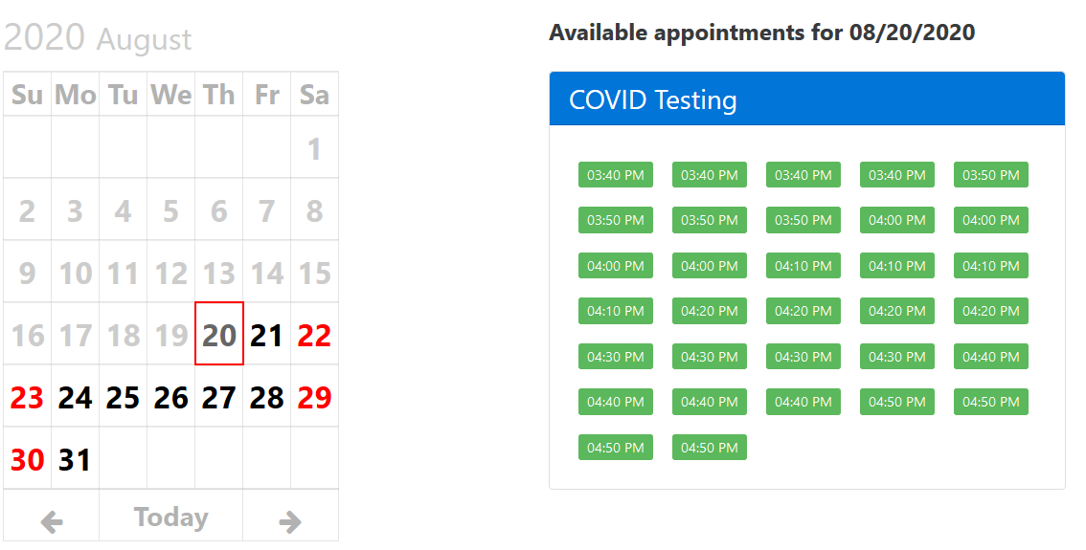
- The appointment will be listed on the patient portal home screen and you will receive an email confirming the appointment from noreply@medicat.com.

