Completing the Symptoms Tracker on the Patient Portal
Follow the instructions below to complete the Symptoms Tracker Form on the Patient Portal.
Access the portal directly at https://umassd.medicatconnect.com or by selecting this box
on the UMassD Health Services website https://www.umassd.edu/studentaffairs/health/

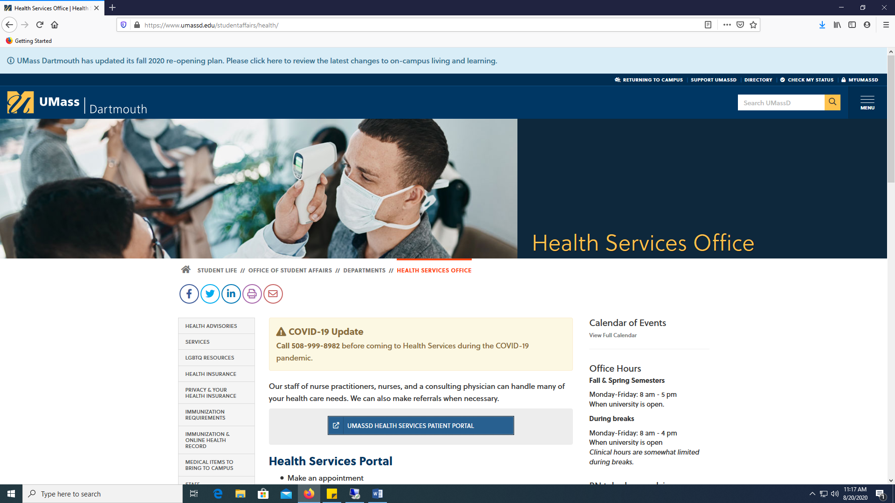

- Log into the Portal with your UMassD username and password.
- Select the COVID-19 button.
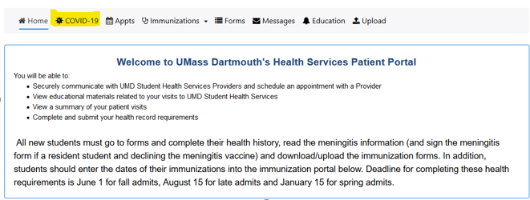

- Click the Symptoms Tracker Form.

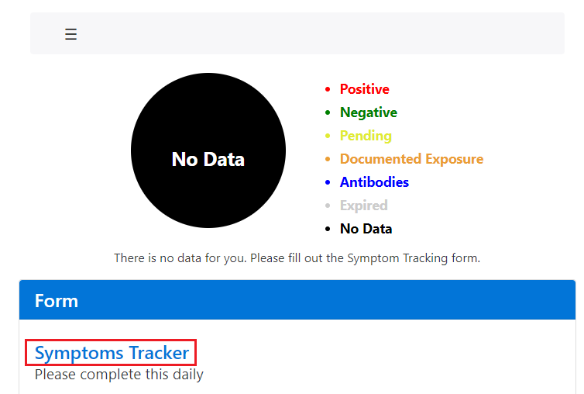

- Complete the questions and select Submit when done.

- Your COVID Status will update on the Portal. You will see a colored indicator of your current COVID status.
  - Expired (Gray) = your status is now expired, and you need to complete the Symptoms Tracker Form again to update your status
  - No Data (Black) = you do not have a status. This is typically your status before you complete the Template Tracker Form for the first time.
  - Negative (Green) = you are negative for symptoms or exposure. You are cleared to attend class and/or be on campus.
  - Documented Exposure (Orange) = you have indicated a possible exposure to COVID-19 on your Symptoms Tracker Form. Please stay home and quarantine for 14 days following exposure. Please contact Health Services through the secure portal or call Health Services at 508-999-8982 during normal business hours for further instructions.
  - Pending (Yellow) = you have a COVID-19 test pending. Please isolate until results have been received.
  - Positive (Red) = you have indicated COVID-19 symptoms on your Symptoms Tracker Form. Please stay home and isolate for 10 days. Please contact Health Services through the secure portal or call Health Services at 508-999-8982 during normal business hours for further instructions.

- Please complete the Symptoms Tracker Form daily to update your COVID Status.

