Center for Indic Studies Announces
”India’s Ancient Wisdom in Modern Business & World Affairs”
FALL 2012 Seminar Series
Mahatma Gandhi Distinguished Lecture 2012

Friday, October 12, 12noon - 2pm
Woodland Commons, Parking Lot 7
UMass Dartmouth Campus (Old Westport Rd.)

The Spirit of Gandhi is Alive and Well and Living in East Boston
A Special Tribute to
UMass Dartmouth Prof. Emeritus, Gene Sharp
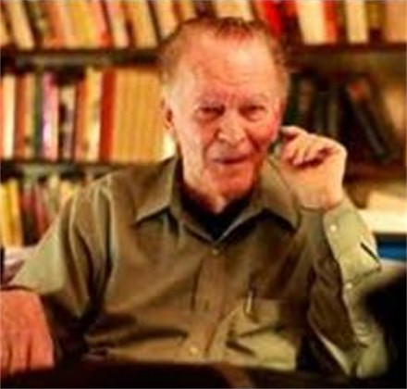

FREE and OPEN TO PUBLIC – light refreshments (served at 11:45AM)

Gene Sharp, PhD, an emeritus UMass Dartmouth professor, has been publically acknowledged as, “…the man who changed the world.” (Boston Globe editorial, Feb. 12, 2011). University of New Mexico sociologist, Sharon Nepsted adds, “Thanks to Sharp, we can now realistically envision a world without war.” Twice nominated for the Nobel Peace Prize, the subject of a full-length award winning documentary, the brains behind the successful nonviolent strategies of “Arab Spring”, the dictator’s worst nightmare, the author of 11 books, translated into 27 languages, and the world’s foremost expert of nonviolent intervention, we honor our colleague Gene Sharp for his contributions to UMass Dartmouth, to the world at large, to peace and justice, and a nonviolent future for generations to come.

Thursday, Oct. 11, 6pm–9pm, Sci & Eng Rm 227, Parking Lot 13 Screening of “How to Start a Revolution,” followed by panel discussion.
For further information see www.umassd.edu/indic/, or contact: jsolfvin@umassd.edu
