Center for Indic Studies Announces
Spring 2013 Seminar Series
Change That Matters

“Contemplative Practice & Happiness”
Friday, Feb. 15, 12noon – 1:00pm
Claire T. Carney Library, Grand Reading Room, 122

Jerry Solfvin, Ph.D.
Center for Indic Studies
UMass Dartmouth
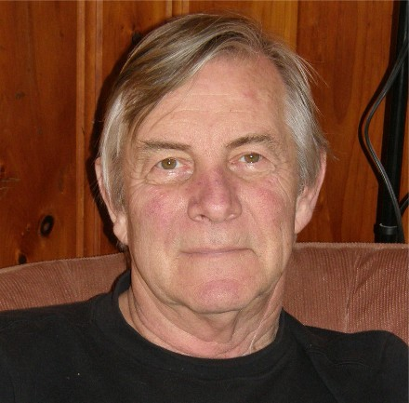

FREE and OPEN TO PUBLIC – light refreshments (served at 11:45am)

RADICAL CHANGE is underway in the study of “mind”. The old “mind” science: 1. Assumed the “mind” (and person) must “be” in the brain; 2. Identified brain anatomy, states, and traits and asked “what’s wrong with this “mind””; and 3. Built theories, models, and therapies around the goal of fixing what’s wrong. The overwhelmingly successful new approach: 1. Views person-mind as a nonlocal “process”; 2. Asks, “what is a happy person/mind?”; and 3. re-establishes the central role of “attention” in understanding “mind”. Dr. Solfvin will discuss some Indic influences driving this.

Jerry Solfvin, PhD., is a member of the Center for Indic Studies faculty. He has published on scientific methodology, nonduality, meditation research, and on the rich, untapped potential of yoga & parapsychology to which western science is yet to “wake up”. Former affiliations include, San Francisco State University, California Pacific Medical Center, California Institute for Integral Studies (CIIS), and Duke University. He was an invited NIH panelist, a founding member of the Esalen Institute DMILS workgroup, recipient of grants from Harvard University Hodgson Fund, Institute of Noetic Sciences (IONS), The Nathan Cummings Foundation, and a UMass Public Service Grant.

For further information see www.umassd.edu/indic/, or contact: 508-910-6630/ jsolfvin@umassd.edu
