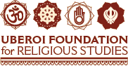
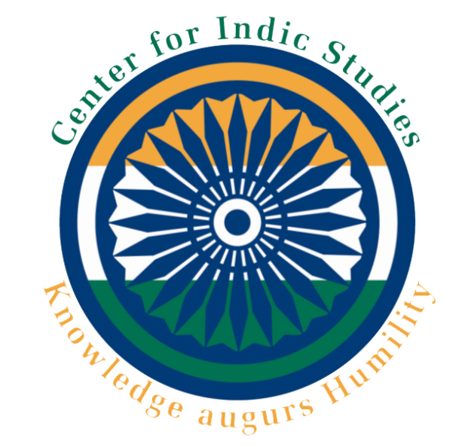


Uberoi Foundation for Religious Studies
Workshop on Teaching Dharmic Traditions

2012 Summary, Feedback Report, and Future Strategies

Submitted by

Bal Ram Singh, PhD
Director, Uberoi Teacher Training Program
Director, Center for Indic Studies
University of Massachusetts Dartmouth
Phone: 508-999-8588
Fax: 508-999-8451
Email: bsingh@umassd.edu

Coordinators: Dr. Maureen Hall, Department of Education
Ms. Shivi Chandra, Center for Indic Studies

Program Assistants: Ms. Maureen Jennings
Ms. Hollie Jones
Ms. Sirisha Mukkavali
Mr. Alok Gadgil

Uberoi Foundation for Religious Studies
Workshop on Teaching Dharmic Traditions

2012 Summary, Feedback Report, and Future Strategies

Program Summary

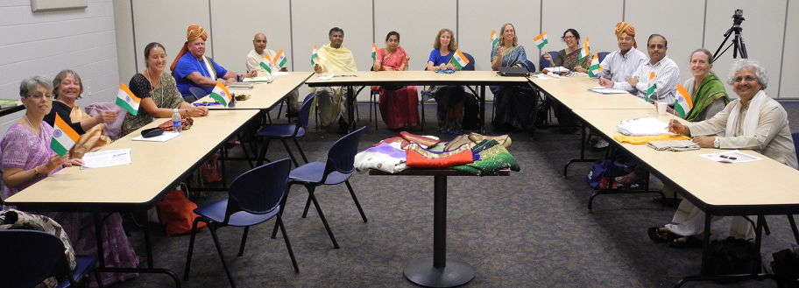
The third year of the Uberoi Foundation Workshop on Teaching Dharmic Traditions was held during the last week of July. The details this workshop is as follows:
Teachers, Program Organizers, Uberoi Foundation officials at the teacher training program.

Workshop
July 23rd-27th. 6 teachers. A total of 14 applications/inquiries received. 8 applicants were accepted. Two of the accepted applicants developed family emergencies, so could not participate.

Before arriving at these workshops, the participants were asked to familiarize themselves with an intensive booklet compiled by the Center for Indic Studies (CIS) which contained chapters on the four Dharmic Traditions prepared by Dr. Anantananda Rambachan (Hinduism), Mrs. Kamlesh Kapur (Buddhism), Mr. Pravin Shah (Jainism), and Dr. Arvind Pal Mandair (Sikhism). These authors were selected for their expansive scholarly and practicing knowledge of their traditions, as well as their experience in relating information to non-practicing communities.

Topics for the presentations and seminar sessions were selected by a group consisting of:
Dr. Bal Ram Singh (Center for Indic Studies) - Director
Dr. Maureen Hall (Department of Education) - Coordinator
Ms. Shivi Chandra (Center for Indic Studies) - Coordinator

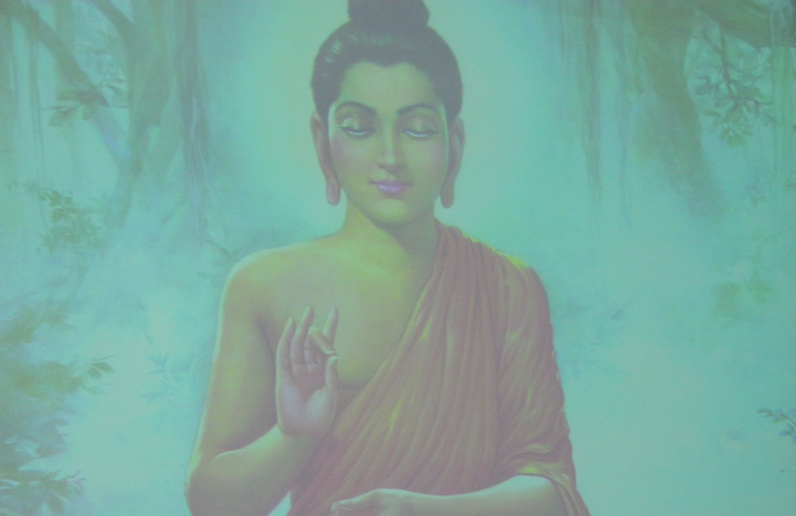
After analyzing the content and structure of the 2010 and 2011 Uberoi Workshops, this team decided to incorporate a methodological approach to teaching Dharmic Traditions, focusing on teaching strategies and helpful lesson approaches to the subject matter in addition to relaying pertinent information about the traditions. In response to feedback from the 2010 and 2011 Workshops, the team decided to model teaching strategies within the context of the presentation strategies themselves. Some of the aspects of this methodological approach included the following:

- Shorter presentation times (approximating those teachers actually have in the classroom).
- Interdisciplinary topics suggesting ways to incorporate the Dharmic Traditions into the standard curriculum framework.
- Integration of content from the readings, activities, and discussions into dynamic lessons on the Dharmic Traditions for the K-12 classroom.
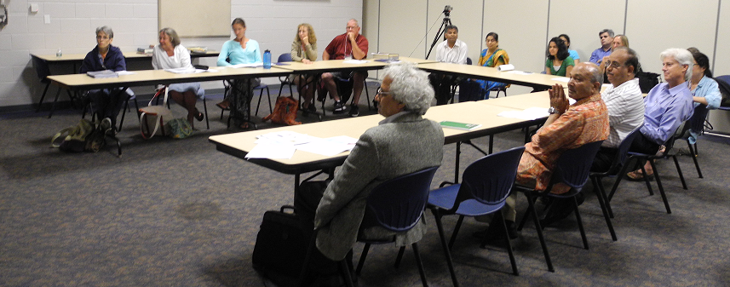
- Providing the teachers adequate time to work on their lesson plan assignments.
A presentation session

The Workshops were divided into five days: General Introduction, Hinduism, Buddhism, Jainism and Sikhism, and Conclusion. A list of topics and scheduling can be found on the Uberoi Workshop schedules, attached. The presenters for individual topics included:
Dr. Bal Ram Singh (Center for Indic Studies)
Swami Yogatmananda (Providence Vedanta Center)
Dr. Maureen Hall (UMass Dartmouth)
Dr. Jerry Solfvin (Center for Indic Studies)
Ms. Shivi Chandra (Center for Indic Studies)
Mr. Steven Brown (Buddhist presentation)
Pt. Ramadheen Ramsamooj (3R Foundation)
Ms. Harkiranpreet Kaur Dhaliwal (UMass Dartmouth)
Mr. Yogendra Jain (JAIN temple)
Dr. Kumar Nochur (Shri Lakshmi Temple)

In addition, Uberoi Foundation Chair, Prof. Ved Nanda, Vice Chair, Pravin Setia, Executive Director, Jim Polsfut, and Secretary, Katherine Nanda, participated and interacted with teachers and instructors.

Participants enjoyed full workdays beginning at 8:30 A.M. with breakfast and meditation and stopping between 4 P.M. and 5 P.M. Immediately preceding or following dinner were vibrant evening programs reinforcing the week’s theme of cultural familiarity, including:
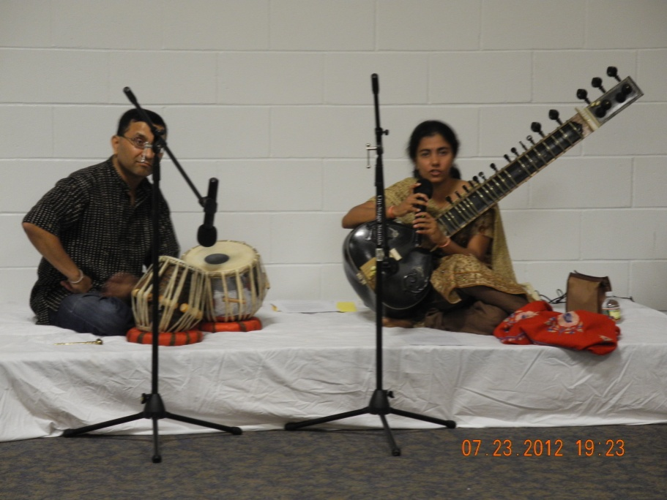
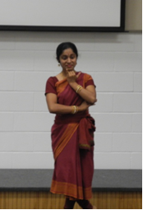
-A classical Hindustani music concert with live performance and lecture from Ms. Koyel Ghosal, a trained sitarist, accompanied by a tabla player.
Koyel Ghosal with sitar explaining the beauty of Indian classical music to teachers
Anuradha Tata explaining communication through expression in Indian classical dances

-A presentation by Dr. Maureen Hall showcasing her unique Fulbright Scholarship work all over India.
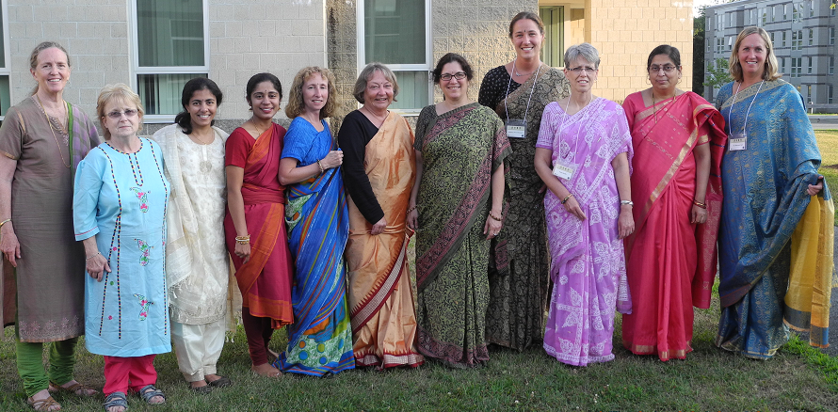
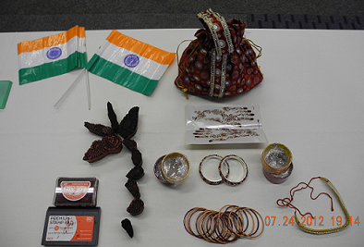
- Celebration and “trying-on” of Indian outfits (saris, lehengas, dhotis, kurtas, turbans) and jewelry by all teachers and organizers.
Display items showing the cultural practices in India.

-Visits and tours to a nearby Hindu temple in Ashland, Mass, a Sikh temple in Everett, Mass., and a Jain temple in Norwood, Mass., with dinner provided at the Jain temple.

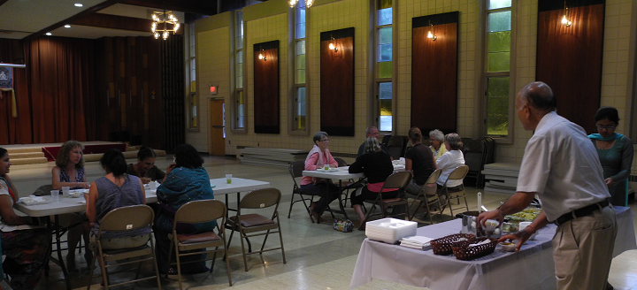
On the last day, teachers showcased and discussed drafts of the two of the lesson plans they had been designing throughout the program with assistance from the Uberoi staff, as well as their plans to continue working on the final four lesson plans mandated by their fellowships. All expressed a desire to continue working with the Center for Indic Studies and Uberoi Foundation, as well as an interest in organizing events at their own schools for further understanding of and involvement with Dharmic Traditions.

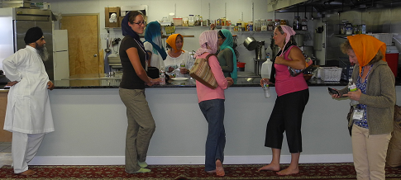
Teachers ready to begin their day, shown here in the Workshop. Teachers worked collaboratively with other participants and the presenters and were able to plan lessons, research information, and even explore along with presenters as the day proceeded.
Teachers visiting a Gurudwara in Boston

Coordinators

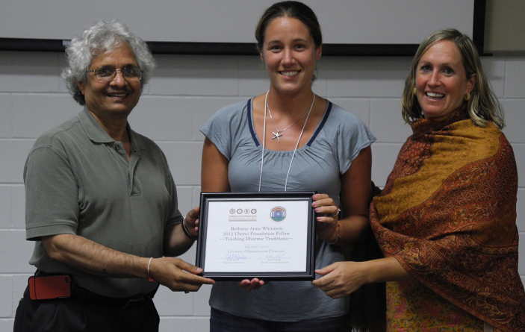
Welcomed teachers to the workshops, established standards for lesson plans, and ensured welcoming environments from the first day. Dr. Bal Ram Singh, Director of the Center for Indic Studies, and Dr. Maureen Hall, an Associate Professor of Education at UMass Dartmouth and Fulbright-Nehru scholar affiliated with the Center, were instrumental in creating this environment and facilitating the days' activities.
Teachers received a formal Uberoi Teacher Fellow certificate after completing the training program
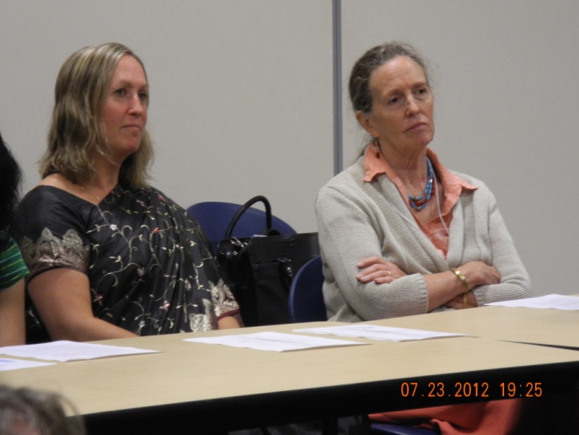
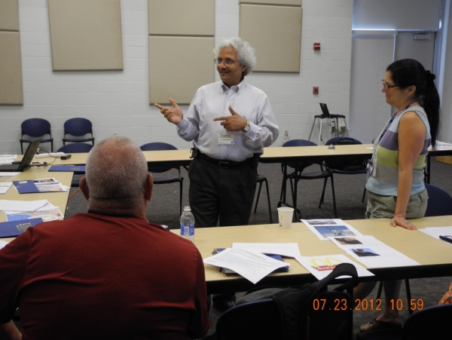
The intimate environments of the Workshop, the small group setting with 6 teachers, and the focus on building a strong rapport and community within the group were noted by all teachers. Presenters and coordinators remained with the Uberoi fellows throughout, always available for questions, ideas, and of course, socializing.
Teachers are engaged under watchful eyes. Program Coordinators and even Uberoi Foundation officials are constantly available

Feedback Compilation

The Center for Indic Studies solicited detailed feedback from all its Uberoi fellows and allotted approximately 45 minutes on the last day to provide answers on a feedback form.

*****************************************************************************

Uberoi 2012 Feedback Questions for Participants:
1. What elements/experiences were most/least interesting to you as a high school teacher?

2. What elements/experiences were most/least interesting to you as an individual?

3. Follow-up: How will you follow up on new ideas/insights for building knowledge on Dharmic Traditions and improving learning in your own context; what collaborations do you think you may build?

4. Please comment on the usefulness of all the presentations and presenters.
5. Planning for next year (suggestions, etc...)
***************************************************************************
Themes Emerging from each of these feedback questions:
Question 1: What elements/experiences were most/least interesting to you as a high school teacher?

Theme One from the feedback involved:

Clearing up of misconceptions/ misperceptions about the Dharmic Traditions.

Quotes from participant feedback, Question 1:

"I came to this workshop with a large amount of ignorance about the traditions of the Indian Sub-continent...The most interesting portion was any subject that went into great detail so I could lift this veil of ignorance and start to engage the traditions."
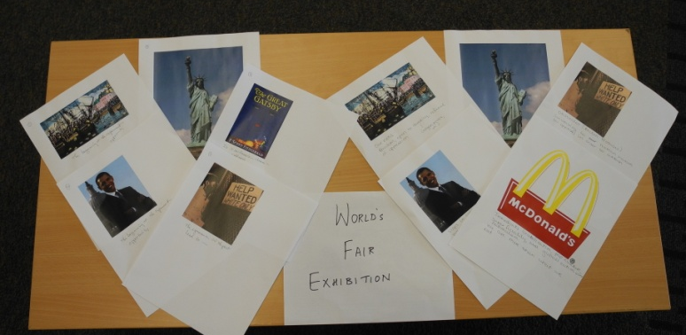
"This fellowship has been fabulous. There wasn’t a most/least. I feel like I needed each and every presentation for an understanding. Each not only cleared up misconceptions I had, but had me wanting to know more. I felt like the more I knew, the more questions I had. "The first thing I think I gained was a clearing up of a lot of misconceptions I had about the different traditions. I also found a term to use for these beliefs: traditions. It is much better than beliefs, or religions or such. Additionally, being able to see, hear and experience these traditions brought clarity to my understandings."
Teachers practice portrayal of USA using media resources provided at the workshop.

Theme Two from the feedback involved:

Positive and high level of interest in learning the Dharmic Traditions.

Quotes from participant feedback, Question 1:

"Everything was AWESOME...My curiosity kept growing and growing, and I know I’ll go on to research more and more wherever I can. Most importantly, I felt that the trips to the temples/worship spaces reinforced and encouraged more learning. I feel like this class is only the tip of the iceberg, and I want to continue to further my understanding more and more on my own. If there were a Fellowship, Part II, I would take it."

"I was open to anything that was going to be taught."

"Presentations and discussion of Hinduism, Sikhism, Jainism etc... Buddhism was excellent."

"The SALT method was most interesting. Also very interesting to learn more in-depth about the 4 traditions, which I had thought I had a pretty good grasp on."
"All were interesting to some degree. Most interesting– Bal Ram – History. Food –Learned much about food, diet, philosophy."

Question 2. What elements/experiences were most/least interesting to you as an individual?

Theme One from the feedback involved:

Connections between and among readings, activities, and discussions helped to reinforce learning of the Dharmic Traditions.

Quotes from participant feedback, Question 2:

"All of the different customs, costumes, foods and rituals all gave me plenty of materials to connect to the various writings."
"I really don’t have a least interesting- as everything was connected and reinforcing this experience was enlightening. I knew so little, learned so much."
"Honestly, I was fascinated with everything. The visits to the temples provided clarity and understanding for our previous discussions."
__________________________________________________________________________________
**One participant sought more yoga and meditation practice to complement the theories presented.

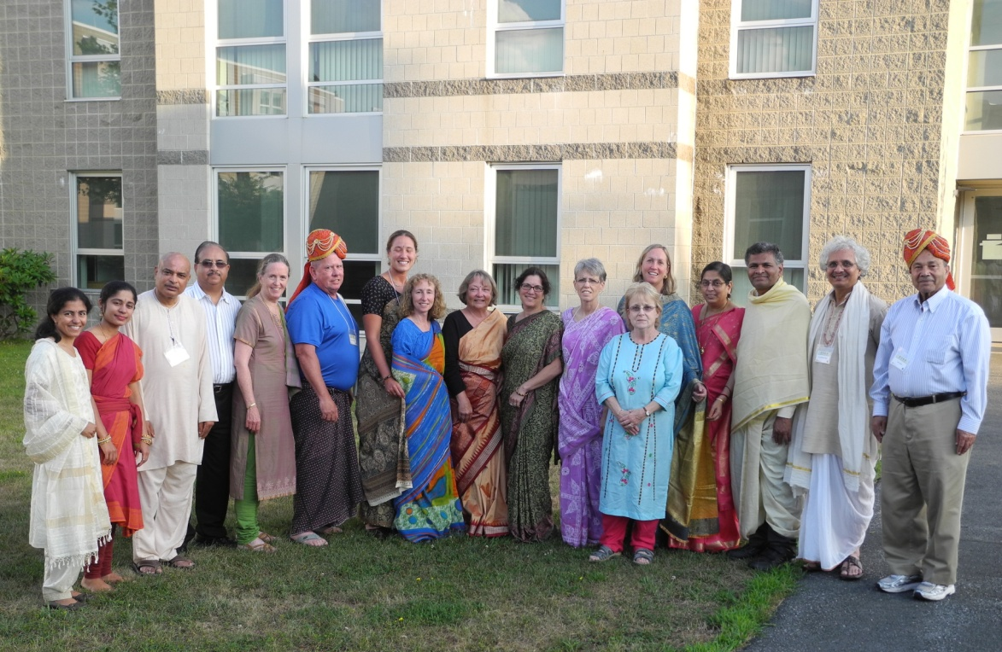
Teachers, organizers, visitors, including Uberoi Foundation officials and trustees at the costume and dress event of the teacher training program

Question 3. Follow-up: How will you follow up on new ideas/insights for building knowledge on Dharmic Traditions and improving learning in your own context; what collaborations do you think you may build?

Theme One from the feedback involved:

Ongoing collaborative efforts with the Center for Indic Studies at UMass Dartmouth and other venues and sources

Quotes from participant feedback, Question 3:

"I definitely am interested in staying connected with the Center for Indic Studies center on campus and recommending some of the programs to my students. I also plan on exploding the way I teach world literature. I definitely want to integrate more world cultures in my curriculum, so this has encouraged me to seek out new works."

"Attend events offered by Indic Studies."

"I will pay attention to follow up courses and events that will increase my opportunities to learn more about the Indian Sub-continent cultures."

Question 4. Please comment on the usefulness of all the presentations and presenters.
This section does not have themes, but it does have feedback on various presenters.

Quotes from participant feedback, Question 4:
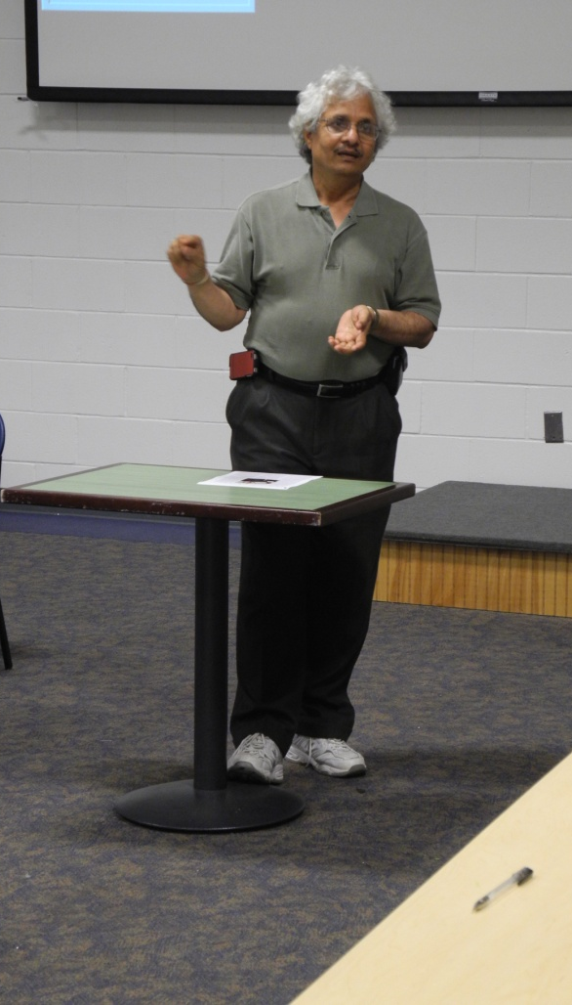
Dr. Bal Ram Singh presenting to teachers.
Bal Ram Singh: History and Geography:
-"Very good history and geography, but it appeared that Bal Ram needed more time to enjoy and help us appreciate this portion of the workshop. I think by moving the schedule around this presentation, especially due to the amount of detail involved, could flow more smoothly."
-"I think that this was a great way to ground the course, because it really gave us an idea of the enormous diversity of the country."
-"History and Geography- incredible!"
-"Opened my eyes to a whole new world."
-"Great intro and background for the week."

Maureen Hall: Teacher Expectations:
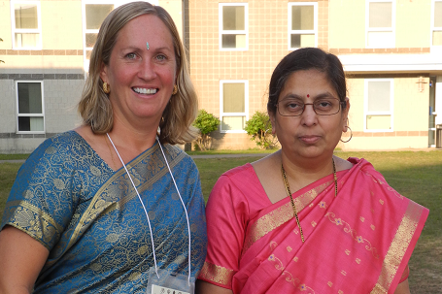
-" I appreciate Maureen’s viewpoint on the teacher expectations for the workshop. The expectations of the teachers, especially in the beginning, seem overwhelming when a teacher hasn’t digested ALL the information yet. This could also be pushed further down the schedule to reduce the anxiety which was easily ameliorated by the field trip."
Dr. Maureen Hall with Mrs. Mani Parayitam, wife a faculty at UMass Dartmouth
-"This was a very practical and specific presentation that came at the right time. That way we knew what was expected to. This helped my OCD a lot because I was able to visualize what I was going to have to do."
-"Very concise and well prepared as well as interesting."
-"Good to have a plan to implement and put into practice. This was useful to me."
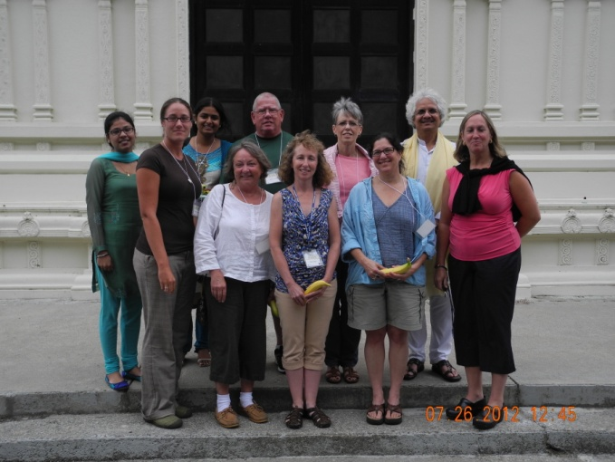
-"Very clear on what is wanted."
Teachers in front of Sri Lakshmi Temple in Ashland, MA

Hinduism: Swami Yogatmananda:
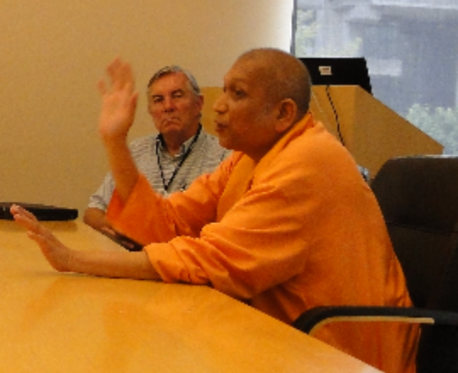
-"I thought that Swami Vivekananda was excellent because he personified the Hindu tradition. I enjoyed his philosophy and the fact that he shared his beliefs, as well as, he addressed us directly about our understandings of Hinduism based on our 'education' to date from this workshop."
-"AWESOME. I loved him the minute he walked in. His smile and serenity was evident in his face. I thought his quiet, gentle presentation was just so powerful because you could see in his face that he was living what he believed."
-"Just a great explanation."
-"Clear, simple, layman terms, made this easy to understand complexity of practices/beliefs."
-"A very interesting person."

Controversial Issues/ Contemporary Issue for Dharmic Traditions: Shivi Chandra:
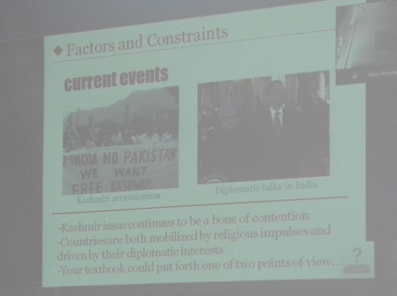
-"I enjoyed Shivi’s overview and her in-depth knowledge. I think having her on the first day was a little confusing due mainly because I was just “learning about Dharmic” tradition and had not really gotten to the point where I was aware that there were confusions. I think the first day should be an overview and historical information and a day of introduction, but Shivi’s take would be more easily digested from Day 2 on. "
Shivi Chandra integrated current events in the teaching models for teachers to discuss Dharmic traditions for modern times.
-"Shivi is an amazing resource. The way that she broke things down was SO relevant to our teaching of it in high school. I thought that her depth of knowledge and presentation of it was great. It is also great that she gave us her PowerPoints because they’re great. I know I would be making all kinds of mistakes if I didn’t have Shivi’s presentation."
-"I loved all her PowerPoints, lots of good information, great presenter."
-"Realistic, straight forward – useful to teachers. Clear about how to present what we have learned."

Buddhism: Steven Brown:
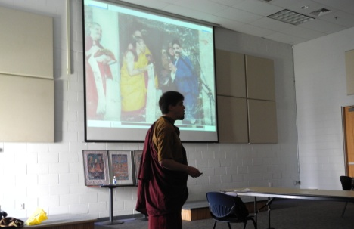
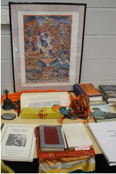
-"I found this presentation to be well done and relatable. He was personable and made his adventure into Buddhism seem “do-able.” I know that some people found his first talk to be too fast, but I didn’t have a problem with either presentation. I learned a lot about Buddhism and appreciated his overview."
Steve Brown presenting Tibetan Buddhism practice.
-"He was fascinating. I thought his translation was amazing, but it may have gone on too far. I feel like he could have taught us so much more in that time. However, I loved the information he gave us and thought his life story was just as interesting. He would be a great (short) guest speaker for kids, especially because nowadays they have so little conviction."
-"Truly in love with his tradition."
-"A bit too much info to process."
-"Interesting life and life path. He is a reminder to use the anti-stereotype “regular” guy = Buddhist."

Meditation and Yoga: Jerry Solfvin:
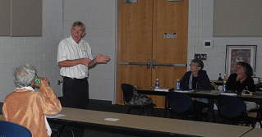
Dr. Jerry Solfvin at the Teacher Training Session
-"It was interesting to see Jerry’s view of meditation, especially when later on we were exposed to 2 other speakers who performed meditation differently. I guess this emphasizes that within the Dharmic Tradition there is a lot of variety."
-"This was a great way to start the day. What I loved best is that he brought in Christians with Buddhist tendencies (meditation). I think that that goes far in teaching kids that this isn’t “some crazy new age thing.” He, too, was so full of peace and calm. Loved it."
"Great job."
-"Great!"
-"Ideas of meditation – helpful and great way to model the practice."

Jainism: Yogendra Jain:
-"I found this presentation to be very informative, but needed the field trip to reinforce the correct Jainism information. I liked that he provided a workbook that was extremely organized and helpful."
-"Yogendra was really informative and interesting. I hadn’t realized how closely this is tied to science they were. This would be great to teach kids, though we can’t really do that. I can introduce it to them and hopefully peak their interest. I also appreciated the fact that he gave us a book, so that we can use them as a reference without having to search websites. All of the information is right there at our finger-tips.
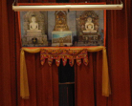
-"Really explained this topic well."

-"Good for the teachers as he packaged it to use for high school students. With connections to environment, health issues, behavior."

Meditation and SALT Pedagogy: Pandit Ramsamooj

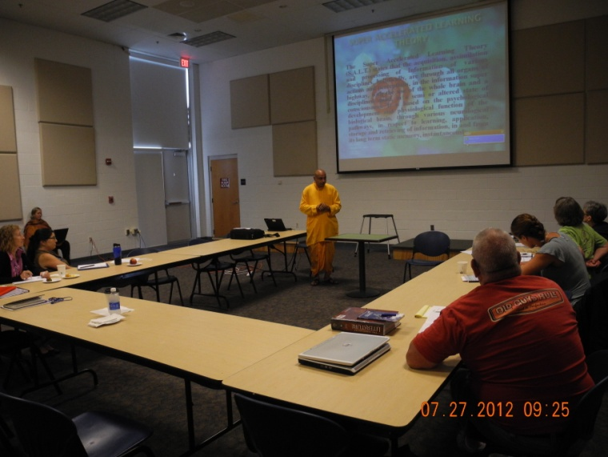
-"Even though I have been working with Pandit Ramsamooj for the past year and have been aware of his SALT theory for the past 15, I become aware of nuances each time I see his presentation and I really appreciate the review."
Pandit Ramadheen Ramsamooj describing the SALT education model inspired by learning methods of Vedic culture. This session captures teachers’ attention the most as they can use it in their classroom.
-"This was fascinating. Wish I had more time on this. I wanted to know more in practice and what it looks like."
-"Pandit is a very engaging and erudite; he is a great presenter."
-"Entertaining. I am going to get more info on this."
-"I liked the meditative element and the 'whole' education ideas. To see students as part of a cosmic process is within my own belief system. I will work harder to get students to become involved with this method."

Sikhism: Harkiran Kaur:
-"I really enjoyed this presentation. Harkiran did a beautiful presentation and was very informative; I especially found the historical portion to be interesting. "
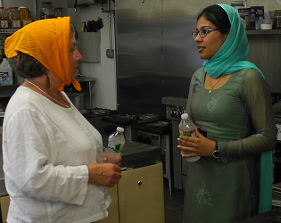
-"Harkiran was great. She was so knowledgeable and clearly proud of her tradition. She had so much information to give and it was made real when we visited her worship site the next day."
Harkiranpreet Kaur Dhaliwal engages one of the teachers explaining Sikh Langar practice
-"Fascinating."
-"The history part was a bit long but she was great."
-"Impressed by her knowledge, poise, and approachability."

Any feedback on field trip to Hindu/ Sikh/ and Jain Temples:
-"The firsthand experience of meeting the leaders of the temples along with walking through the temples and having the ability to ask questions improves the working memory of Dharmic Traditions as they are enacted in modern times. I enjoyed this field trip and would recommend that this aspect of the workshop be repeated."
-"EXCELLENT – A MUST! PERFECT! WOULDN’T CHANGE ANYTHING."
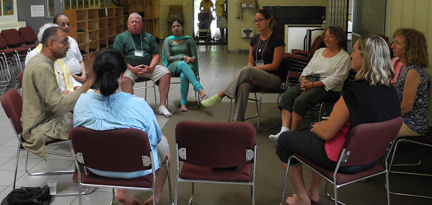
-"I feel that the trip to the three temples was a capstone experience. To be able to actually see and listen to and speak with the priests and members of the congregations makes it so much more real. To read about it is one thing, to actually experience the temple and the rituals is so much better."
Dr. Kumar Nochur’s session at Sri Lakshmi temple in Ashland, MA describing different aspects of Hindu practice
-"Absolutely necessary! Made an impact on everything we’d previously studied."
-"Loved it!! Real hands-on experience. Meeting the people in context and seeing the places, brought understanding."

Question 5. Planning for next year (suggestions, etc...)
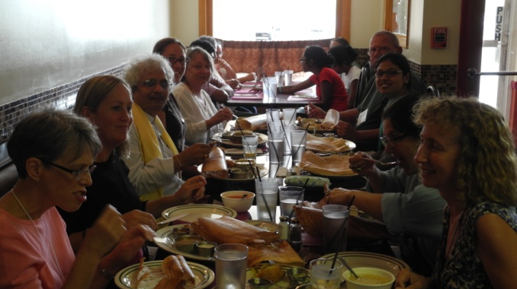
Teachers experience lunch at an Indian restaurant near Sri Lakshmi Temple, Ashland, MA
Theme One from the feedback involved:

More art and architecture connected to the Dharmic Traditions

Quotes from participant feedback, Question 5:

"The Buddhist temple should be visited as well. Perhaps some art and architecture could be brought out next year. Also, as an English teacher, I would have liked to have heard some discussion about current Indian literature."
"More art, current Indian literature (poems, short stories, etc.)"

"I loved the musical and dance performances, as well as the sari night."

Theme Two from the feedback involved:

Comfortable atmosphere --a learning community

Quotes from participant feedback, Question 5:

"The people here – presenters, Maureen, Bal Ram, Maureen, were wonderful. I am going to write the Uberoi Foundation to tell them/thank them for this wonderful gift."
"This workshop was wonderful and I believe that everyone agrees overwhelmingly."
"It was wonderful in the way it was done. I felt so welcomed, cared for, and important each day and at every event. The kindness and care was so appreciated. PS – I was totally impressed with the grad students. So talented, so disciplined, so warm, nice and gracious."
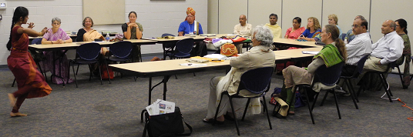
Anuradha Tata demonstrates intricacies and meanings of Indian classical dance
___________________________________________________________________________
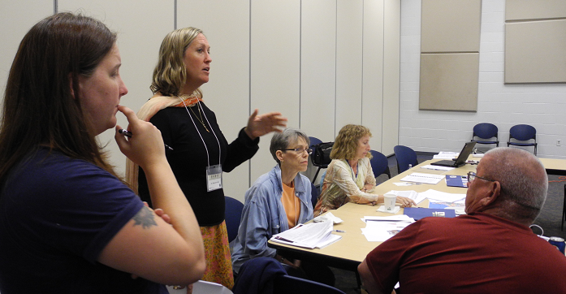
A Sampling of Lesson Plan Titles Completed by 2012 Participants:
Dr. Maureen Hall goes over the lesson plan details

-"Geography: Modern India and Her Neighbors"

-"India/USA--Healthy Environments?"

-"What is India? Traditional? Modern? Exotic? Complex? All of the Above?"

-"World's Largest Democracy-- India?"

-"Indian Poetry to Indian Beliefs"

-"Intro to Indian Culture Prior to Fasting, Feasting"

-"'A Real Durwan' by Jhumpa Lahiri"

__________________________________________________________

Future Strategies

After understanding and analyzing performance and results from the previous three years’ Uberoi workshops, the Center for Indic Studies has determined three umbrella action items from the feedback received that will inform the future trajectory of the workshops:

1. Moving from a focus on lecture-based information delivery towards interactive, methodological, and strategy-focused presentations

2. Assembling a small core team of presenters who share a vision for teacher education and possess experience with the dharmic traditions, the social studies/humanities focus necessary for teachers, and the educational culture of American classrooms

3. Provide or remain involved in the development of concrete teaching materials and strategies for teachers.

More specific suggestions/plans based on these three “action trends” include the following:

-Develop standards for professional development points and academic credits teachers need for their professional advancement. This is a critical point for attracting teachers to the workshop, as PDPs and graduate credit are part of their professional requirements for their promotion and career advancement. We have worked out a course for this purpose in collaboration with the Department of Education at UMass Dartmouth.

-Involve more of the following people in planning and execution: social science/humanities professionals, K-12 educators, and young people with experience in the American educational system. This will ensure more critical thinking about what goals and necessary reforms should be the target of the Uberoi workshop, as well as ensure an understanding of what teachers would like to and need to see most. Speakers that teachers can connect to are most likely to make a difference in their teaching styles.

-Involving young students as part of the workshop in raising and answering questions for teachers to connect with a generation of their audience. Teachers tend to relate to youth opinions more as their students are of the same generation. We have made some efforts by including Miss Shivi Chandra in the workshop, but will plan to have at least a session with more youth members from high school or college.

-Involve past Uberoi fellows as presenters and speakers. Through intensive training at the Center, Uberoi fellows who demonstrate extraordinary initiative and focused effort in making the dharmic traditions accessible to students can be excellent ambassadors to future students. We introduced this plan effectively in 2012 workshop.

-Institute mandatory training for speakers and presenters. This will establish certain guidelines such as what information to include or not to include and greatly circumvent logistical issues such as lack of powerpoints, etc. This will also prevent one of the most common issues in the workshop: speakers contradicting one another or failing to model the methodologies they endorsed.

-Understand that cultural education and metacognitive thinking on cultural education is a field in its own right, and that planners and executors should be acquainted with its general principles. These workshops are not general introductions to dharmic traditions—they are intensive programs on teaching dharmic traditions. A simple encyclopedic provision of information will not be sufficient to fulfill this purpose. In recent years, many useful books, workshops, and strategies have been released on showing teachers about how to teach religious and cultural traditions that are not their own, and the Center will commit itself to making sure speakers and presenters understand basic issues of generalizations, casual racism, and others which confront teachers in the classroom before designing their presentations.

-Clearly delineate what the purpose of the workshops is and is not. By deeply considering teachers’ needs and constraints and ensuring that all speakers and presenters understand these, extraneous or inaccurate presentations can easily be avoided.

-Develop concrete materials for teachers. Guides, quizzes, lesson plans, and other materials will be presented by all speakers. In addition, cultural education experts will prepare a reference booklet containing basic information about the Indian subcontinent and other necessary material that teachers can consult during the course of the workshop.

-Reorganize the structure of the workshop to reflect its audience. The structure and content of the workshop should be designed to reflect teachers’ experiences in the classroom—short 45-minute presentations, frequent activities and mixed media, and plenty of understandable, accessible information, just like teachers strive to provide when they teach. In addition, a more interactive approach is absolutely necessary. One or two speakers instead of so many might be helpful in maximizing continuity and familiarity as well.

However, in order to implement these suggestions the Center’s most critical need is for a team of similarly-minded personnel who have all of the following qualifications:

-Enough academic or practicing experience with the dharmic traditions and the field of Indic studies to answer questions, identify common controversies and problems, and remain aware of what they don’t know.

-Academic experience with issues in cultural studies, namely developments in postcolonialism, race and minority studies, cultural education, and the social sciences dimension of what it means to teach dharmic traditions and Indic studies today.

-Professional experience or qualifications in social sciences fields relevant to the tasks involved in the Uberoi workshops such as identifying pertinent information, thinking critically and abstractly about motivational goals, and adapting important academic or arcane concepts into synthesizable material for teachers

-Full-time dedication to the tasks and mission involved in the Center for Indic Studies’ and Uberoi Foundation’s work.

These qualifications would be best met if the Center were able to employ full-time faculty or graduate students as part of its team, an aspiration which is one of the stated aims of the Center’s 10 on 10 fundraising project, an initiative to raise $10 million in commemoration of the Center’s 10th anniversary. The major aim of this fundraising project is the desire to complete the transition from a Center to a School with its own faculty and professionals on board assisting with projects such as the Uberoi workshops. Full-time faculty and the students brought in for research and other projects would best be able to develop projects like the Uberoi workshop to its full potential. The Center is committed to ensuring the improvement of this program as time goes on.



