ELMO DOCUMENT CAMERA FOR ART DEMO (AVAILABLE AT THE VML HUB)

Connecting an Elmo Document camera to a PC

- Plug in the Document Camera to the wall outlet.

- Connect the USB cable to the Document Camera and the USB connection on the laptop

- On the PC, type Camera into the search box next to the Start menu.

- Select and launch the Elmo Document Camera application

- Turn on the Document Camera

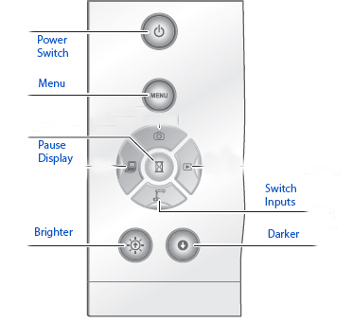

- Use the camera controls to switch between your Document Camera and your laptop screen.

- Share your screen while in a Zoom meeting to display the contents of the Document camera.

Connecting an Elmo Document camera to a Mac

- Plug in the Document Camera to the wall outlet.

- Connect the USB cable to the Document Camera and the USB connection on the laptop

- On the Macbook, type Photo Booth into the Spotlight search box.

- Launch the Photo Booth application

- Turn on the Document Camera

- Share your screen while in a Zoom meeting to display the contents of the Document camera.

- Use the camera controls to switch between your Document Camera and your laptop screen.

VML Hub - November 3, 2020

