University of Massachusetts Dartmouth
Visual & Media Literacy Hub
Internship Application
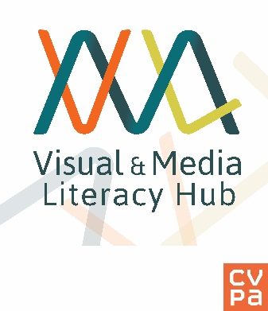

Title of Internship:
Credit Hours:
Semester:
Start Date:
End Date:
No. of Weeks: ______________

Hours Available to Work:
Mon: _______Tues: _________Wed.______
Thurs:_______ Fri:______________
Internship are typically 130 hours (3 hours homework x 1 credit hour) over a course of semester.
Objectives and Description of Internship:
- Managing and cataloging digital collections based on national standards.
- Perform library research related to cataloging
- Assist with daily operations of a VRC including digital production, reference and maintenance of a digital collection
- Learn basic technical and descriptive metadata standards as it relates to digital media
- Hands on experience with media production, creation of database records and media digital asset management systems

The internship offers hands-on-experience by performing a variety of tasks related to collection management including:

Date
Student
Students will become familiar with the methodology, procedures and practices of digital
asset management outlined and advocated by the Visual Resource Association and other museums and library professional standards. Students will gain knowledge and experience with managing visual resource materials within an academic setting and utilize their academic skills to conduct research and development of descriptive metadata records.
Student:
Campus Address:
Permanent Address:
Phone: Email:
Faculty Supervisor:
Internship Supervisor:
Telephone:
Telephone: 508-999-8701
Email: acywin@umassd.edu
Allison J. Cywin

