Chartfield Lookup
Job Aid

The Chartfield Lookup – has been rewritten and you won’t notice any big differences from the one you have been using.
Location – it is located on the same page where you have been accessing it, whether on your Campus page or the UMASS President’s Office – UITS Services Page
We are going to switch the link in December 2020.
UITS - Services Page

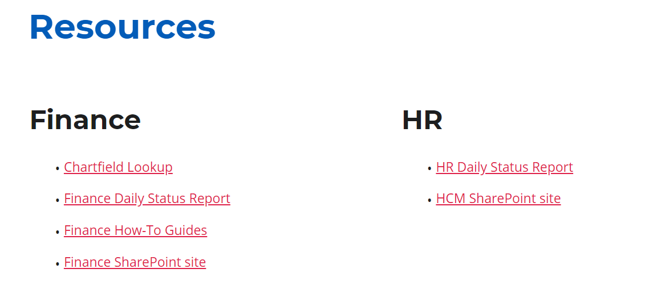
**When Opening for the first time or if having any issues, clear your browser cache,
close the page and open a new page***
The new version looks like this:
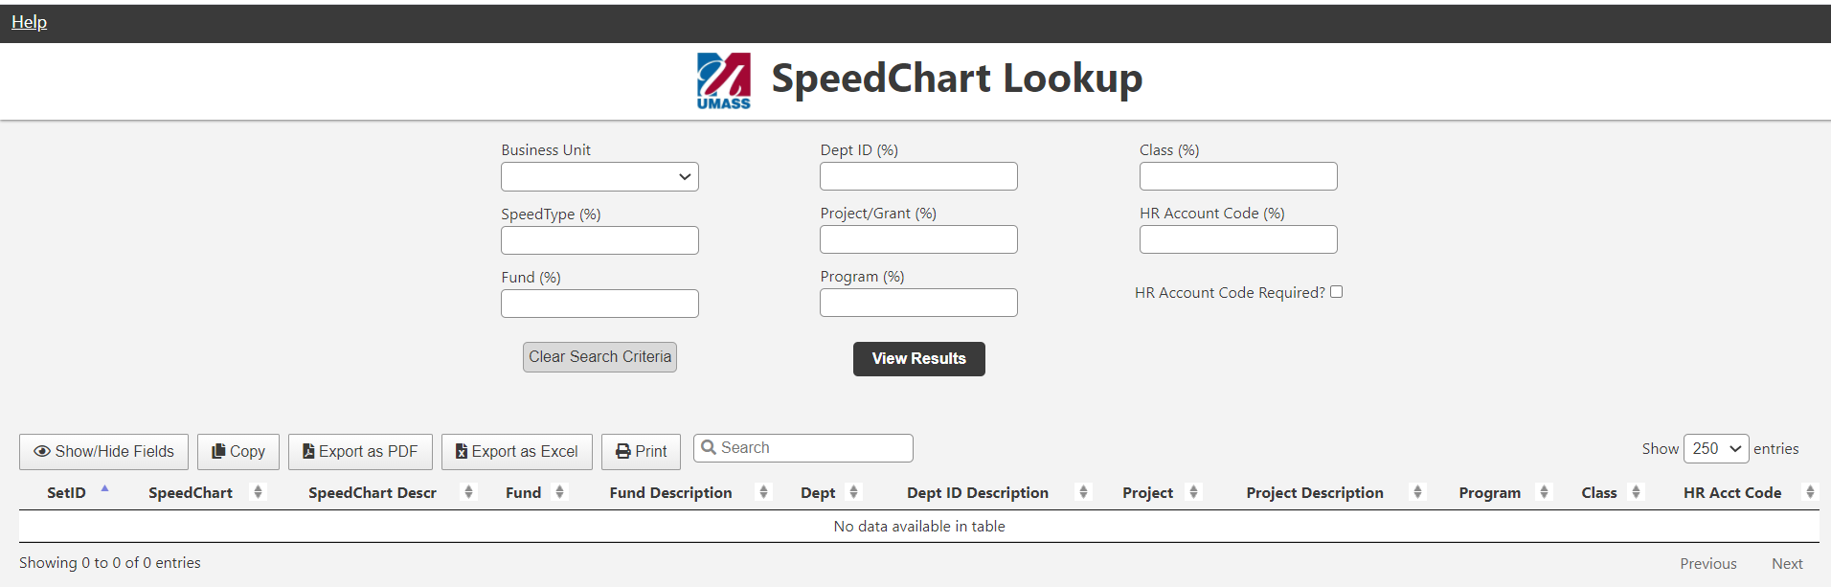
Remember to select your Business Unit (required)!
Use the drop down list
All the other fields allow you to use the Wildcard percent sign (%) to help you narrow down the search for what you are looking for
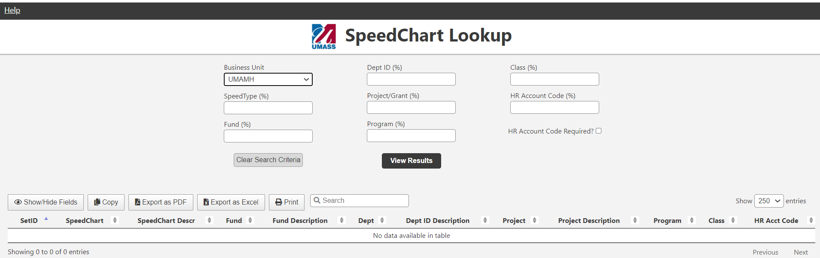
If you know the Speedtype enter the 6 digit number
For the example below, enter UMAMH business unit and speedtype = 129700
Then click on [View Results]
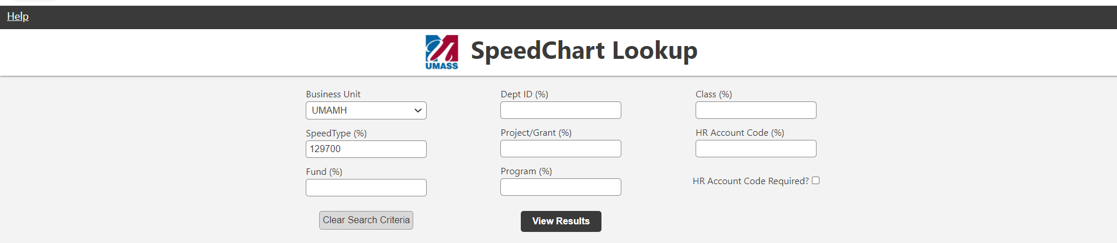

One row is returned
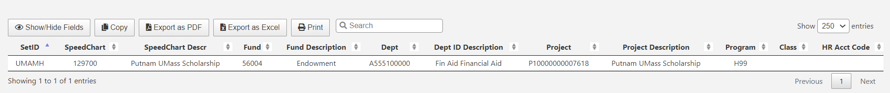

If you don’t know the exact number, use the wildcard (%)
You can enter the speedtype as:
1297%
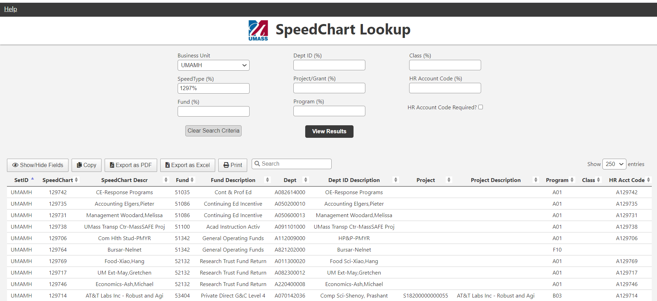
Multiple rows are returned that begin with 1297_ _

Or use the Wildcard (%) in front
%9700
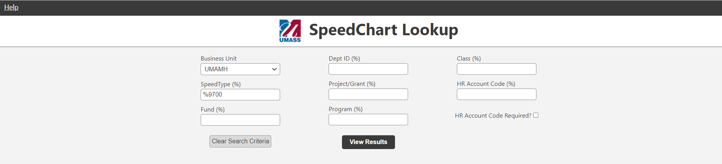
Multiple rows are returned that End with _ _ 9700
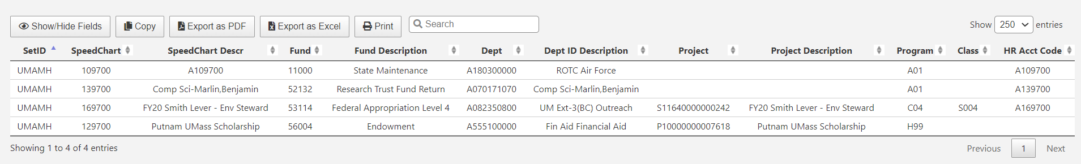

Or use the Wildcard (%) in multiple places
1%97%
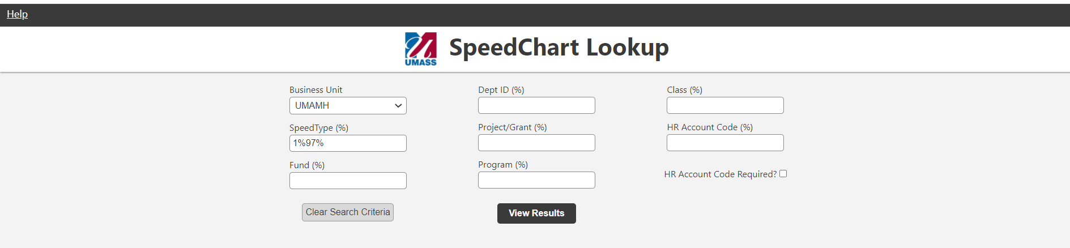
Multiple rows are returned that Begin with 1 and have 97 as part of the rest of the Speed Type number
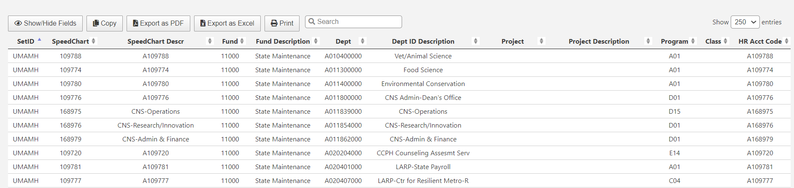

You can also enter one or multiple Chartfields to find the speedtypes that you are looking for
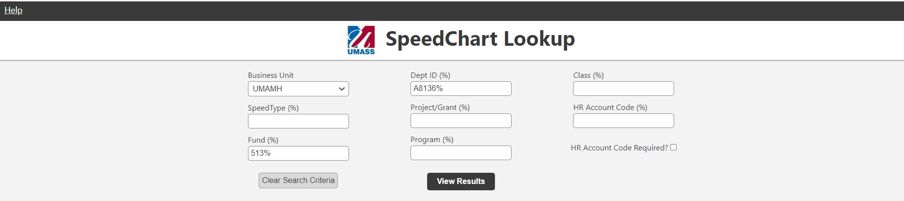

Here are the rows that are returned
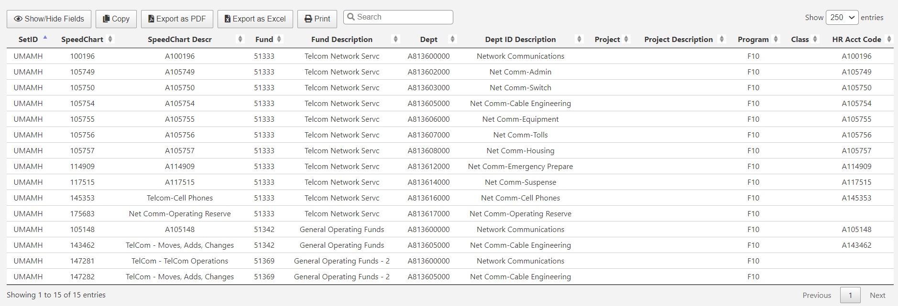
Other Features:
To extract results:
- Print
- Copy
- Export to PDF
- Export to Excel

Clearing Selection fields:
- There is a new option to clear search data – select the [Clear Search Criteria] button

This will blank out the selection fields so you can enter a new selection
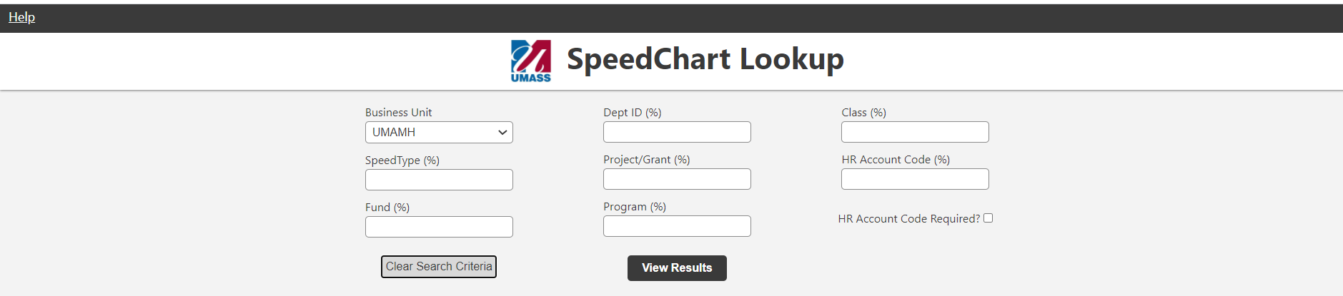

Using different character case (Upper or Lower Case):
- You can enter characters as upper case – (i.e. A812300000) or lower case – (i.e. a812300000) and it will bring back your selection results

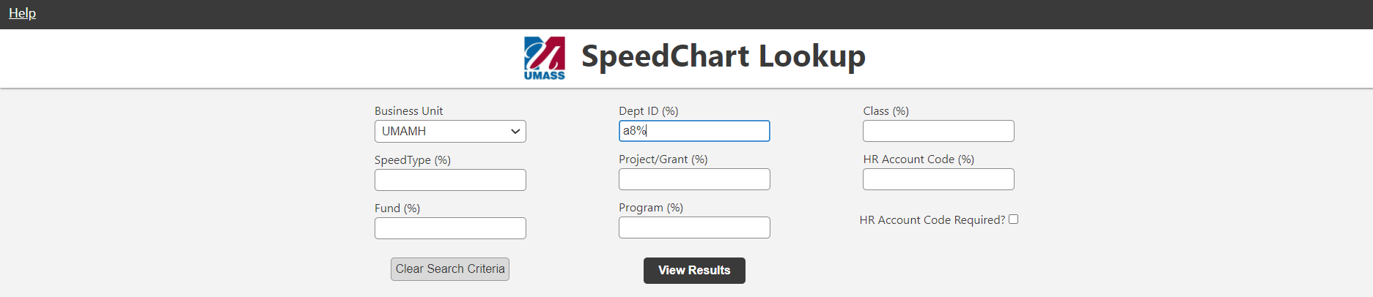

To see the job aid click on the [Help] link
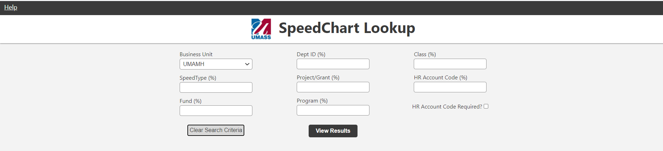

The size of what you are seeing on the screen can be impacted by your display settings
You can also do one of the following to change the size of what you are seeing on this page.

To change the size of this page:
Making what’s being displayed larger - Hold the [Ctrl] key and hit the [+] key as many times as you want
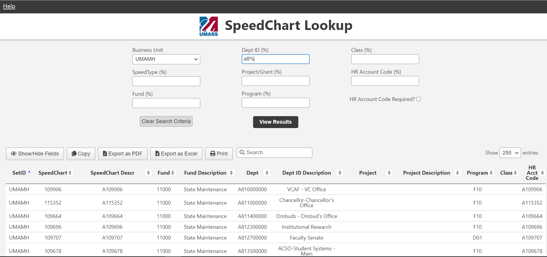
Or
Making what’s being displayed smaller - Hold the [Ctrl] key and hit the [-] key as many times as you want
