Chartfield Lookup Tool
Use the Chartfield Lookup tool to enter a Speedtype and obtain the department/fund/project/program code associated with the speedtype.
Or use the tool to obtain a Speedtype by entering a department, fund, project, program or any combination.
Speedtypes are used on transactions such as purchase orders. Chartfields (department, fund, project, program code) are used as criteria for financial reporting.

Access the Tool
To access the tool, use this link: https://chartfield-lookup.umasscs.net/
Or navigate to www.umassd.edu/peoplesoftfinance/ Financial System Links
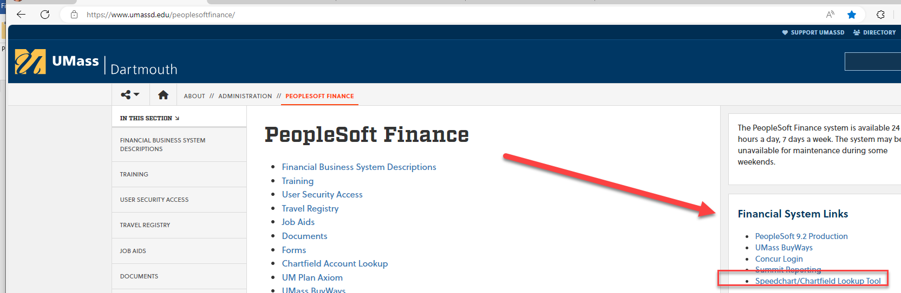

**When Opening for the first time or if having any issues, close the page, clear your browser cache, open a new page.
The newest version looks like this:
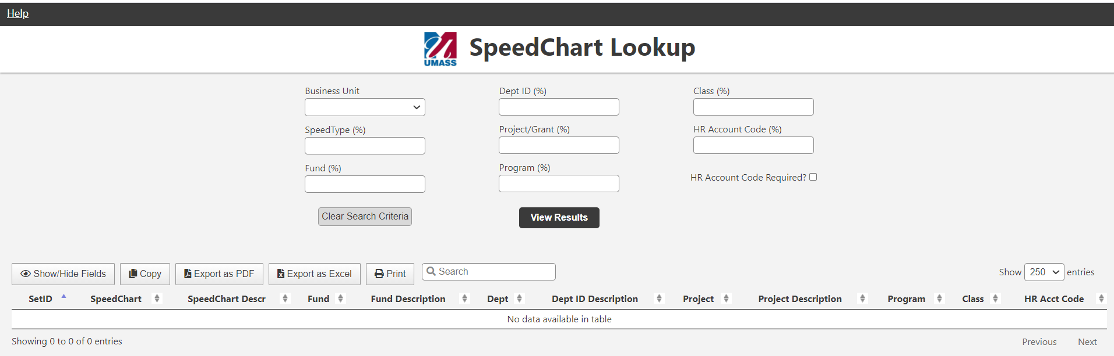

- Select the Business Unit using the drop-down list (required)! = UMDAR
- All the other fields allow the use of the wildcard (percent sign %) to help narrow the search results
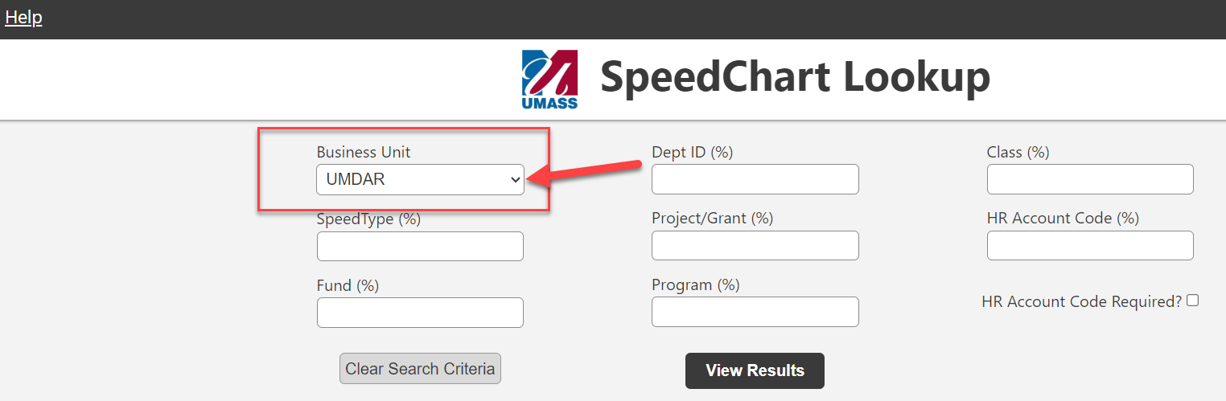

Enter the Speedtype to retrieve the chartfields associated with the Speedtype
- Enter the 6-digit Speedtype number
- In example UMDAR= Business Unit and Speedtype = 101829
- Then click on [View Results].
- One Row of data is returned. With the Fund code, Department and Program Code as well as the HR equivalent of the speedtype
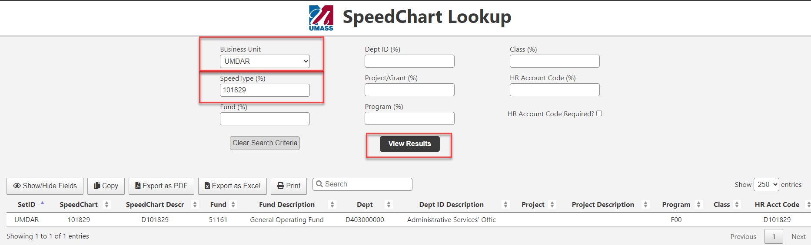
- If the exact speedtype number is not known, use the wildcard (%).
- Enter a partial search. For example, set the speedtype = 1018%. Next, [View Results]
Multiple rows are returned that begin with 1018_ _
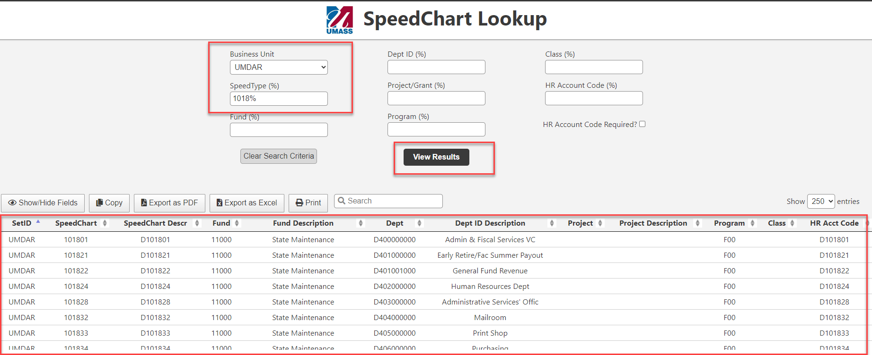
- Or use the Wildcard (%) in front: %101 to retrieve all speedtypes that end in 101
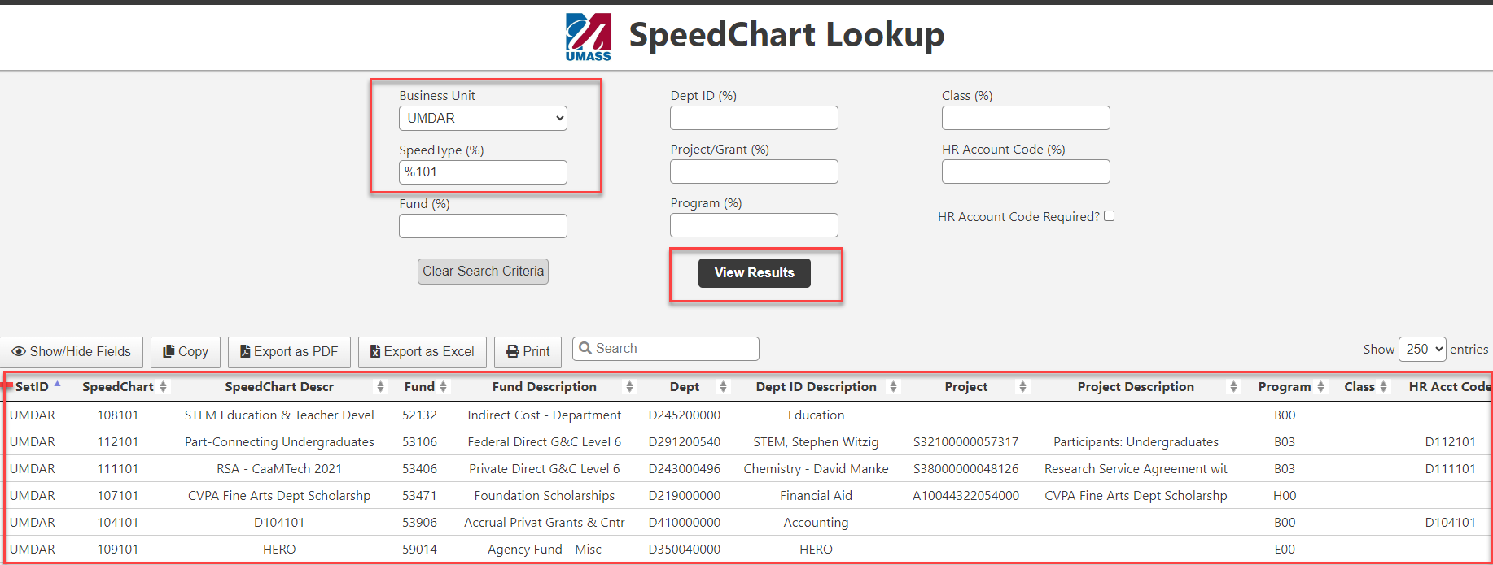

Enter Chartfield(s) to find a Speedype(s)
- One or multiple Chartfields may be entered to find a Speedtype(s). Use the wildcard(%) to perform partial searches.
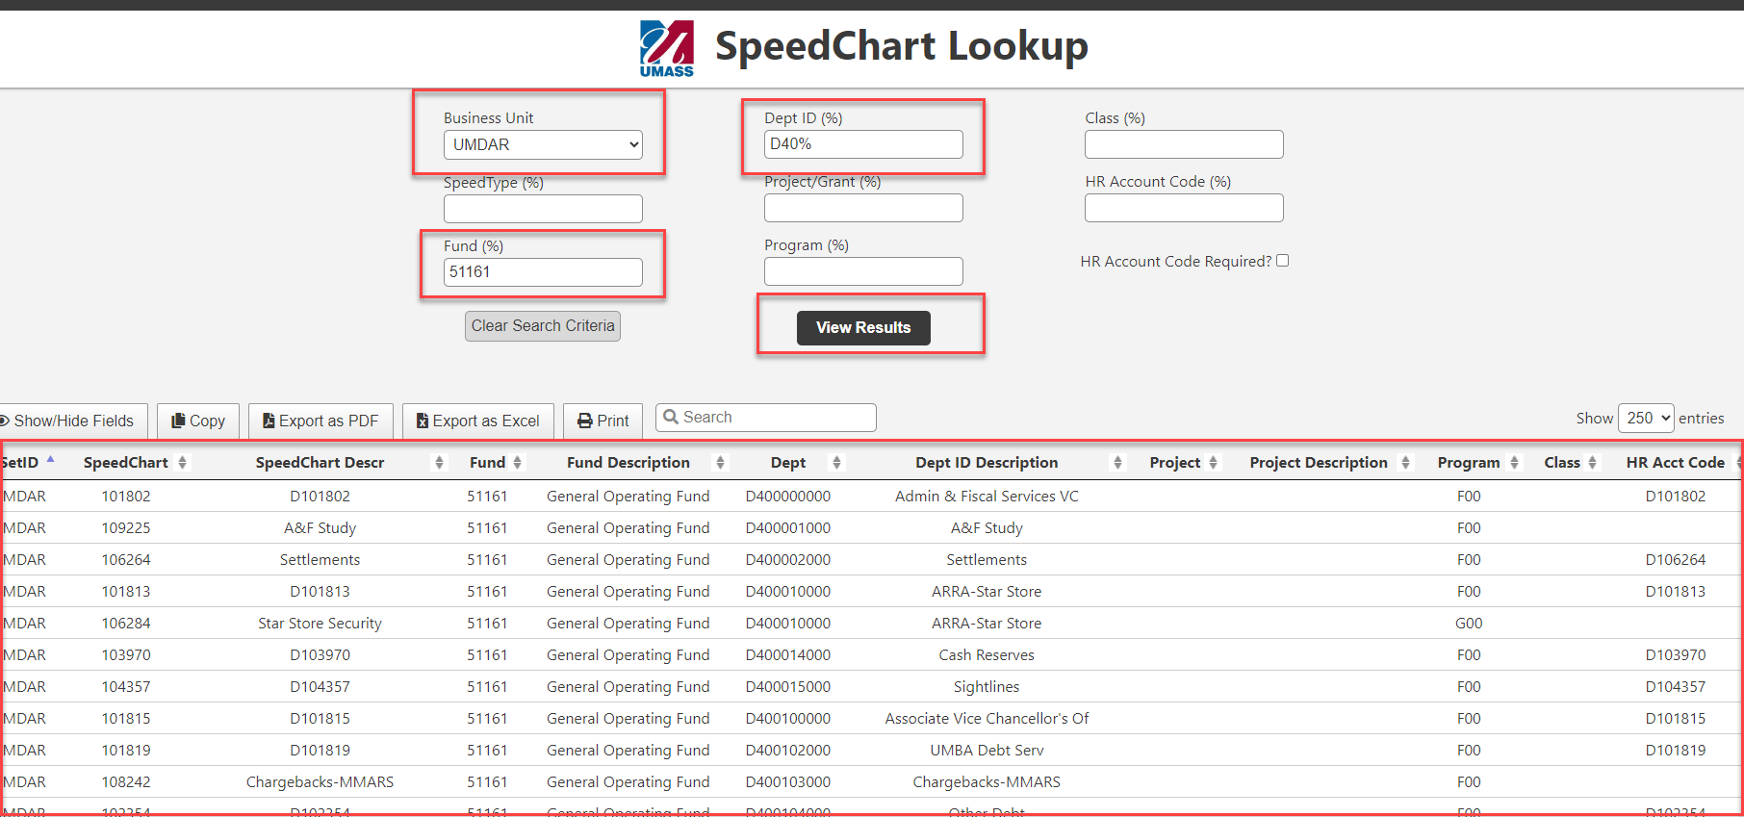

Extract Results
- There are several features to extract results:
- Copy
- Export to PDF
- Export to Excel
- Print
- Show/Hide Fields
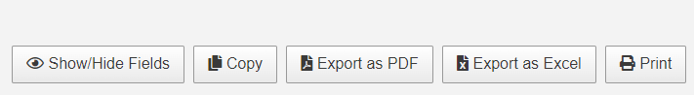

Clear Selection Fields
- There is an option to clear search data – Select the [Clear Search Criteria] button
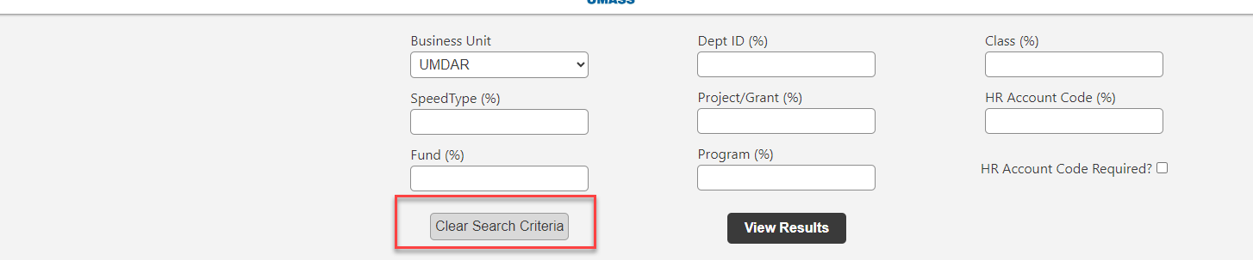
- Business Unit Remains, and Dept and Fund are cleared.

Job Aid
- To retrieve the job aid, click on the [Help] link in the upper left of the page.
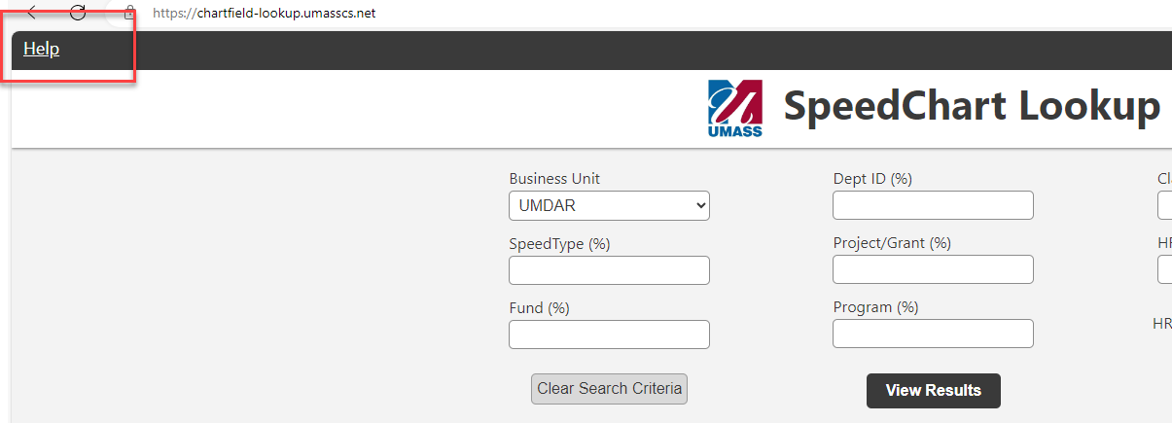

Change the Display Size
- The size of the page displayed on screen may be increased or decreased.
- Place the cursor in one of the fields
- Hold the [Ctrl] key and hit the [+] key to increase the page size.
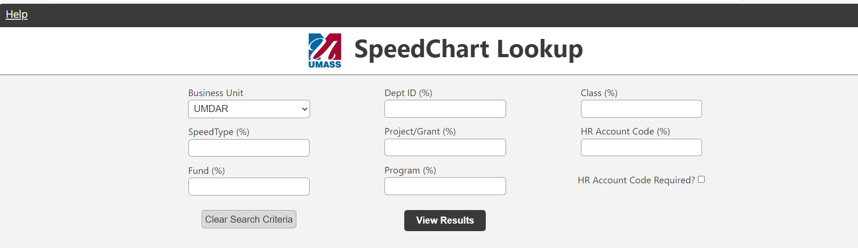
Or
- Make the displayed results smaller: Hold the [Ctrl] key and hit the [-] key

