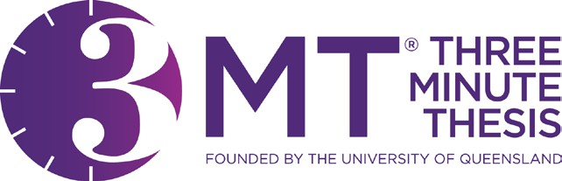

GRADUATE THREE MINUTE THESIS COMPETITION
2026 Registration Form

Registrant Agreement
To be eligible a graduate research student must fulfill the following criteria:
- be a currently enrolled Ph.D. or Master’s degree student who has formally enrolled for thesis or dissertation research credit;
- not be on leave of absence, lapsed in good standing, completed, or withdrawn;
- have approval of their major advisor to present the research;
- your presentation in the University of Massachusetts Dartmouth Three Minute Thesis Competition 2026 represents your original research;
- prior year winner(s) may participate only if the research is on a different topic than was presented previously;
- you have read and understood the rules and judging criteria;
- you accept the judge’s decision is final; and
- University of Massachusetts Dartmouth may photograph, film or broadcast this event.

Student name: Student ID number: Campus email: Telephone: Program of study: College and Program of enrollment: Research supervisor(s): Title of your presentation:

Student signature and date:

Research Supervisor
By signing below, you agree that the student has completed a substantial portion of their research and has sufficient results to share.
Advisor signature and date:

Completed forms for graduate students must be submitted via email to apgradstudies@umassd.edu prior to 5:00 PM on Monday, April 6, 2026.

PLEASE NOTE: We will only have space for 30 participants. In the event that this number is exceeded, preference will be given to those students who are graduating in 2026. Please direct any questions about eligibility or the competition to Office of the Associate Provost for Graduate Studies (apgradstudies@umassd.edu).
HELPFUL HINT: Your talk should break down into roughly three sections: 1) what you are doing, 2) how you are doing it, and 3) putting into context the significance of your research.

