Master Syllabus
Course: ARH 200, Modern-Contemporary Art
Cluster Requirement: 1C

Course Overview:
This class is an introduction to the study of contemporary art and visual culture. Students will learn how to look at and understand contemporary art from various theoretical and methodological perspectives of the scholarly discipline of art history. In addition, the course is designed to strengthen students’ reading and research skills. Above all, it aims to improve students’ writing skills. By the end of the semester students will demonstrate intermediate information literacy skills.

Learning Outcomes:

Course-Specific Learning Outcomes:

Students who successfully complete this course will be able to:
learn about some of the key methods that art historians and critics use to organize and analyze information about art and design objects;

- study examples from contemporary art, while analyzing them according to main methods that art historians and critics use;
- gain valuable information about today’s art and design worlds;
- read critically and interpret and evaluate art historical texts;
- develop a foundation for writing good critical essays about art/design objects;
- conduct research about an art historical topic (and one of interest to them);
- deliver effective presentations for other artists and art critics;
- learn to document art-related texts and images at the UMD library, CVPA’s Visual Resource Center as well as online scholarly databases;

University Studies Learning Outcomes:

Students who successfully complete this course will be able to:
- Expand on the skills they acquired in ENL 101 and 102 and apply them to images;
- read with comprehension and critically interpret and evaluate written work in discipline‐specific contexts;
- demonstrate rhetorically effective writing (especially on topics that involve images) for appropriate audiences in sciences, social sciences and humanities;
- develop research abilities in fields that require analyses of images and objects in material culture;
- demonstrate, at an advanced level of competence, use of discipline‐specific control of language, modes of development and formal conventions;
- demonstrate intermediate information literacy skills by selecting, evaluating, integrating and documenting information gathered from multiple sources into discipline‐specific writing.
In addition, the course will enhance students’ ability to:

- have a deeper understanding of one’s place and role in US society, through writing and presentation assignments that require one’s own original viewpoint;
- think critically about humanity and society, by studying the main theories in the disciplines of cultural studies and art history;
- understand the importance of global cultural perspectives, by examining global works of art and visual culture of the non-west.

Examples of Texts and/or Assigned Readings:

The following required book can be purchased at the UMD bookstore:
- Practices of Looking: An Introduction to Visual Culture by Marita Sturken and Lisa Cartwright (2009)
Optional:
- Robertson, Jean, and Craig McDaniel, Themes of Contemporary Art: Visual Art after 1980, 2009
- D’Alleva, Anne Methods and Theories of Art History, 2009
- Rosenwasser, David and Jill Stephen, Writing Analytically, 2008

**All other assigned readings can be found as pdf files on MyCourses

Example Assignments:

*Exams – The course will have Two non-cumulative exams (the exams include essay questions; multiple choice questions; and definitions of key terms and theoretical concepts)

*Formal analysis – This essay is to be a formal analysis of a work of art. A formal analysis is an analysis of the form the artist produces; that is, an analysis of the work of art, which is made up of such things as line, shape, color, texture, mass, composition. Students will be reminded that a formal analysis differs from description in that it argues a thesis and that a formal analysis connects effects with causes, showing how the described object works – it is concerned with how form makes meaning. In 5 pages, students are asked to discuss: a) Subject Matter; b) Formal Elements (line, shape, value, color, texture,…); c) Organization (rhythm/repetition, balance, scale, composition); d) Choice of Medium; e) Artist’s Intentions. Each paragraph is self-contained; however, each paragraph should flow logically from the paragraph that preceded it, and should lead logically to the next paragraph (in other words, there has to be a thread that carries through the paper). This assignment accommodates goals of Cluster 1C-1 and 1C-3 of new Gen-Ed studies. Students are asked to peer review their colleagues’ papers. The following table shows the grading criteria for peer reviewing:

Rubric for Peer Reviewers

- Please comment on flow, word choice, clarity, paragraph structure, logic, grammar, sentence structure and organization (write your comments on the actual paper). Then, fill out this rubric and bring to class along with your colleague’s paper.
- Simply place an X in the appropriate boxes.
Requirements | Yes | No
Non plagiarized (i.e. the author used her/his own language, did not cut and paste text from the web or anywhere else without citing sources appropriately)
Introduction is clear (i.e., the author begins by describing the work + tells us what her/his paper is going to be about). Author tells us what his/her claim or interpretation of the work is and how he/she will then prove this claim in the rest of the paper.
There is an argument (i.e., the “so what?” question is raised) and this argument is clearly organized into readable paragraphs.
Conclusion is clear (either in form of a summary or a strong point) . This should be a paragraph not just two sentences.
Structure (typed double-spaced) and correct length (i.e., 2-3 pages)

*Interpretative paper – Students will have the option of choosing one of the five topics (Appropriation in Popular Culture; Consumerism and Taste; Gaze and Gender; Identity and Semiotics/Iconography; Virtual Reality and Cyberspace) for their second writing assignment or the “interpretive essay.” The paper must not exceed 8 pages. They may include footnotes. But this is not a research paper; it is a creative writing project (i.e., an assignment that aims to evaluate students’ understandings of issues discussed in class as well as their ability to examine these issues in relation to an artwork and their own personal experience and artistic taste). This accommodates goals of Cluster 1C-1 and 1C-3 of new Gen-Ed studies.

*Interactive Reading Practice- This assignment is designed to help students develop practices of active reading and writing. At various points throughout the essay, they will be asked to stop and comment in preparation for answering relevant questions. As they progress through the essay their responses should be more and more in depth. This assignment would assess students’ reading skills. It examines whether or not they can read with comprehension and critically interpret and evaluate written work in specific contexts. This assignment will be graded with either as ✔, - or ✔+. The following table shows the grading criteria:

Grading Rubric for Interactive Reading Assignment
- | ✔ - | ✔ | ✔+
Assignment turned in late | Writing lacks consistency and the train of thought is difficult to follow; it contains punctuation and grammar errors; student addresses the questions with  descriptions that do not go beyond simple descriptions; the length of each answer is less than 200 words. | Provides ample answers for each question (200 words or more); supports ideas with specific examples where applicable, but the points do not necessarily work with the ideas discussed in the texts; the writing contains punctuation and grammar errors; the response could benefit from  more in-depth analyses. | Addresses the question with specific  examples and insightful  analyses; the writing is devoid of punctuation and grammar  errors; ideas are presented with precision; student is capable of contextualizing an issue within the framework of previous readings and examples discussed in class.
60 – 69% | 70-79% | 80-89% | 90-100%

*Presentation and annotated bibliography – This is a research project. Students are required to write an annotated bibliography, an introduction to a paper they would write with this research, and a conclusive final paragraph. In total, this is a 6-paragraph, 3 page research assignments. The goal of this assignment is to gain experience doing research and giving a presentation. In the written portion of the project, students are asked to follow six steps: Step 1: Select a method of analysis from the list that relates to their artwork: Iconography; Semiotics; Feminism; Cultural Studies and postcolonial theory. Step 2: State a guiding question/thesis statement (for example: If working from a feminist perspective, “Does the choice or treatment of subject matter relate to this artist’s life, and her experiences as a woman?”). Step 3: Select 4 sources (1 from each of the following places) that will help them analyze their artwork: One of the assigned readings from the course: Book; Periodical or Database Article (JSTOR, Art Index, Art Bibliographies Modern, or any scholarly database located through the UMD library web site.); Web site (do not use .com websites; only .edu, .gov, or .org). Step 4 (annotated bibliography): Students are asked to write 4 individual and concise paragraphs on each source. Each paragraph will include the bibliographic reference in MLA style and then will describe how the source helped them answer their guiding question. The purpose of the annotation is to inform the reader of the relevance, accuracy, and quality of the sources cited. Step 5: Students will write an introduction that explains their subject (the artist and their work), the method they chose to analyze the work, and the guiding question. Step 6: They write a conclusion that connects all the selected readings they presented and explains how those sources answered their guiding thematic question. Therefore, their 6-paragraphs should look like this:1) introduction; 2) explanation on how one of the required readings helped them answer their guiding question. What kind of questions emerged from the required reading that helped you find the other sources?; 3) review of the book selection; 4) review of the periodical or database selection; 5) review of the website selection; 6) Conclusion. The assignment has an oral presentation component related to the research project. In addition to writing an annotated bibliography, an introduction to a paper, and a conclusive final paragraph, students must present the content of their research to the classroom. They will each have 10-15 min for this oral presentation. All presentations must be accompanied by slides. This assignment accommodates goals of Cluster 1C-2 and 1C-4 of new Gen-Ed studies.

*In-Class Reading Practices (in-class activity)- Students will be given 10 min to read a selected critical essay in class, in groups of 4 or 5. They will then answer several questions in relation to various aspects of the text; their written answers will be graded but won’t be returned. This assignment Accommodates goals of Cluster 1C-4 of new Gen-Ed studies.

*In-Class Writing Practices (in-class activity) –They will have several in-class writing practices. Each time, they will be given 20 min to write a one page formal analysis of a contemporary work of art; guidelines for writing a formal analysis will be uploaded on MyCourses prior to this week. Ideal analyses of the same pieces will be uploaded on MyCourses afterward for self assessment; these essays will be graded but won’t be returned. This assignment accommodates goals of Cluster 1C-1 of new Gen-Ed studies.

*Image Investigation- Students are required to investigate commercial ads that the capture the characteristics highlighted by in their key readings. They are asked to use the Visual Resource Center. This assignment accommodates goals of Cluster 1C-4 of new Gen-Ed studies.

*Participation – While students’ contribution to class discussions and level of engagement with various in-class activities come into play in figuring their participation grade, the primary factor in their participation grade will be attendance. The following represents the maximum participation grade possible for a given number of absences.

Absences Highest Possible Participation Grade
2 95
3 90
4 85
5 80
6 70
7 60
8 50
9 0
10 or more failure of the course

Artifacts Generated by the Assignments [all accommodates goals of Cluster 1C of new Gen-Ed studies]:

- Formal Analysis Essay (entails mandatory museum or gallery visits; improves writing skills)
- Interpretive Essay (entails mandatory museum or gallery visits; improves writing skills)
- Presentation (improves writing skill and artistic creativity)
- Image Investigation and scholarly sources investigation (improves research skills at the library and via online resources)
- In‐class writings (improves writing skills).
- In‐class readings (involves students’ written responses to instructor’s questions regarding a chosen article).
- Rubrics, peer-reviewed drafts, as well as revisions and responses to feedback.
- Multiple choice questions used in tests and in review sessions.
- Video and audio recorded material (shown in class and available on MyCourses for online discussions).

Sample Course Outline:

SCHEDULE

**************
WEEK 1: Course Introduction

Topic : Remembering and Reviewing the Surveys

An overview of the class, MyCourses, and assignments

Professor’s talk:
Subject: a brief summary of what we did in the past/survey courses; what difference will this class make?

Read:
--Textbook/Practices of Looking. Pp. 311-343 (skim)

Note: Check MyCourses for tips regarding effective note taking and class participation

**************
WEEK 2: What is Art? What is the Canon? Who is the Artist?

Topic 1: Art History Books and the Problem of the Canon; the “Myth” of the Artist

Read:
-- “A World of Art” (Christo and Jean-Claude’s Gates). Pp. 1-4.

--Laurie Schneider Adams, The Methodologies of Art: Chapter 1.

۞.Class activity:
--Examining art history survey textbooks (instructor will bring material to class)

--Discuss reading for Friday: Henry Sayre, “Using Visual Information” in Writing About Art. Pp. 28-59.

Topic 2: Formal Analysis/Visual Analysis

Read:
-- Henry Sayre, “Using Visual Information” in Writing About Art. Pp. 28-59.

۞Class activity:

Class is separated into 9 groups. Each group presents a theme in formal analysis: line; shape and space; light and dark; color and other elements; rhythm and repetition; balance; proportion; scale; unity and variety and construction questions of medium. Then Professor distributes guidelines and asks you to write about a work by Walker Evans in class. Writings will be collected by professor. Both presentations and in-class writing will be graded as part of your “participation grade.”

Note: Check out MyCourses for an “ideal” essay on Walker Evans’s work; be a judge of your own work.

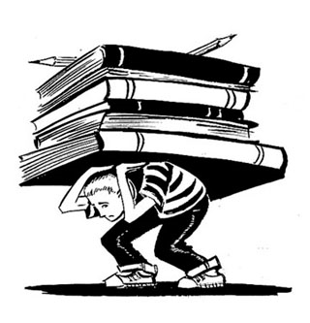Assignment:

Formal Analysis. Go to MyCourses; pick an image out of five available images; write a 3-page formal analysis of the work of your choice. Guidelines and samples are available on MyCourses (read in particular: Sylvian Barnet, “Formal Analysis Versus Description.” Pp. 114-124)

**************
WEEK 3: Mechanisms of Meaning: Formalism; Iconography; Semiotics

Topic 1: The Power of Images

Read:
-- Textbook/Practices of Looking.Pp. 9-37.

Topic 2: Formalism, Iconography, and Simiotics

Read:
--D’Alleva’s Look Again. Pp. 17-45.

۞ . Class activity:

Professor creates some creative visual comparative exercises based on Wolfflin’s Principles of Art History. Then we will analyze “Whistler’s Japanese Mother” to understand the difference between formalism and formal analysis.

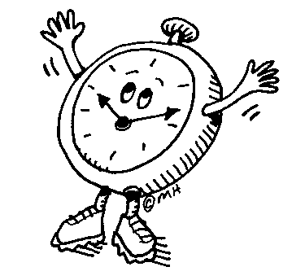 Assignment Due:
Formal Analysis. Bring a draft of Formal Analysis for peer review (your peer reviewer will be chosen by professor). Peer Reviewers will write a one-page summary review of a classmate’s paper, make corrections on the student’s paper (all students make sure that you save the original paper on your computer. You must print out a copy to give to your peer reviewer). Peer Reviewers will also fill out a grading rubric (available on MyCourses) and return to the student.

**************
WEEK 4: Perception and Interpretation
Topic 1: Viewers Make Meaning

Read:
--Textbook/Practices of Looking . Pp. 49-56 AND do the following as you read:

Note:
Find web-based or library-based information (or browse through your textbook glossary) about one of the following scholars/terms; all are addressed in your reading for today; bring written information in the form of an outline to class (these texts will be collected and graded as part of your participation grade, but won’t be returned)/ themes will be assigned on Week 3.

- Althusser and ideology
- Karl Marx and Marxism

Read:
-- Textbook/Practices of Looking. Pp. 56-89. AND do the following as you read:

Note:
Find web-based or library-based information (or browse through your textbook glossary) about one of the following scholars/terms; all are addressed in your reading for today; bring written information in the form of an outline to class (these texts will be collected and graded as part of your participation grade, but won’t be returned)

- Barbara Kruger and text versus image
- Shepared Fairy and pop culture
- Bordieu and taste
- Greenburg and Kitsch
- Michel Foucault and “death of the author.”
- Michel De Certeau and everyday life
- Bricolage
- Appropriation

Topic 2: Introducing the VRC

Visual Resource Center (VRC) staff will help you with finding online resources and using the VRC (Visual Resource Center/ at CVPA).

Assignment:
Interpretive Essay. (Please see MyCourses for the actual assignment and guidelines)

**************

WEEK 5: High Art, Low Art

Topic 1: Taste, Class, and Perception of Art

Read:

--Wallach, Alan. “Norman Rockwell at the Guggenheim”. Pp. 93-113.

--skim:
http://www.pophistorydig.com/?p=9780

Topic 2: Fine Art vis-à-vis Craft

Read:

--Elissa Author. “The Hierarchy of Art and Craft in American Art.” Pp. xi-xxx.

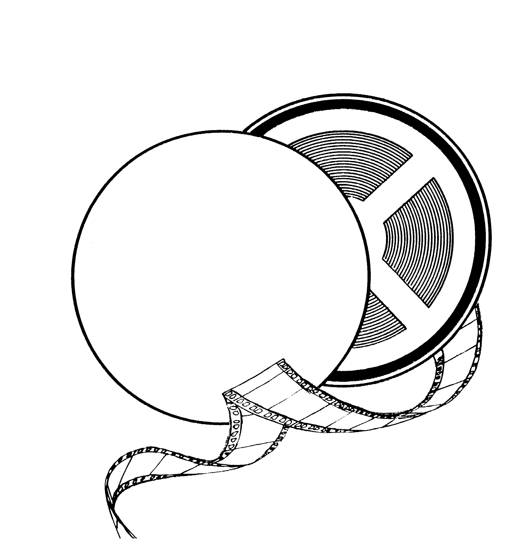Screening:
Video of Josiah McElheny

۞Class activity:

--Writing on the works of Edward Hopper and other writing tips.

**************

WEEK 6: Commodity Culture and Fetishism

Topic: Advertising and Commodity Culture

Read:
--Textbook/Practices of Looking. Pp. 265-304.
--D’Alleva’s Look Again. Pp. 46-60.
-- Roland Marchand. (Excerpts from Advertising the American Dream)Pp. 264-274.

۞Class activity:
We analyze Roland’s visual cliché: Radiant Beams, Adorning Throngs, Heroic Proportions.

Screening:
Excerpts from documentary on the American graphic designer Milton Glaser (take note during the films and submit your writings in class—this will be collected and graded as part of your class participation)

Assignment:
Image Investigation. You are required to investigate commercial ads that the capture the characteristics highlighted by Marchand. Please consult with the VRC specialists.

**************

WEEK 7: The Display of Art

Topic 1: Art in Public: Issues of Power and Ownership

Read:
--Textbook/Practices of Looking. Pp. 104-111.
--Vilis R. Inde, “Richard Serra: Whose Property is it Anyway?”

۞.Class activity:

Classroom turns into a courtroom: A debate for Serra. Are you for or against Tilted Arc?

Assignment Due:
Formal Analysis. Final paper due in class (by this time you must have received comments from your peer reviewers and revised your first draft). Please attach any comments by your reviewer to this final polished draft. Also attach the rubric which is filled out by your reviewer.

Topic 2: Art, Media, and the Public Sphere

Read:
--Textbook/Practices of Looking: Pp. 247-255.
-- James Edward Young on artist Shimon Attie, “Sites Unseen” in At Memories Edge. Pp. 62-89.

Assignment:
Critical Reading. Please start answering questions to “Sites Unseen” as you read the text.

Assignment Due:
Image Investigation. Bring pictures to class: contemporary ads from the web or other resources based on Marchand’s comments on visual clichés: Radiant Beams, Adorning Throngs, Heroic Proportions.

**************
WEEK 8: New Media

Topic 1: What is the Virtual?

Read:
--Char Davies. “Virtual Space.” Pp. 89-103. (skim 69-89)

Topic 2: Perspective: From Painting to Digital Media

Read:
--Textbook/Practices of Looking. Pp. 157-180.

MIDTERM EXAM (takes place in the classroom; you’ll have the entire time to work on a series of essay questions. Please contact instructor in advance if you need to take this exam at CAS)

Note:
Guidelines for Midterm will be uploaded on MyCourses in advance (instructor will notify you via email)

**************
WEEK 9: Gender and the Body: Feminism

Topic 1: Introduction to Feminist Theory

Read:
--Textbook/Practices of Looking. Pp. 120-136.
--D’Alleva’s Look Again. Pp. 60-70.

Topic 2: The Importance of the Gaze

Read:
--Textbook/Practices of Looking. Pp. 113-120.

Assignment Due:
Critical Reading. Please bring all answers to the questions to the Shimon Attie’s article (this will be graded as part of your class participation)

Read:
--John Berger. Ways of Seeing. Pp. 45-64.

۞Class activity:
Debate over Berger’s article: Do you agree with him?; We will work on grammar and sentence structure.

**************

WEEK 10: Regarding the Body of the “Other”

Topic 1: Orientalism and Colonialism

Read:
--Textbook/Practices of Looking. Pp. 355-364.
--D’Alleva’s Look Again. Pp. 76-86.
Excerpts from Edward Said’s introduction to Orientalism. (5 pages on MyCourses)

Screening:

--Excerpts from The Battle of Algiers

Topic 2: Reading the “Difference”

Read:
--D’Alleva’s Look Again. Pp. 70-76.
--Robertson and McDaniel’s Themes of Contemporary Art, “The Body.” Pp. 73-107. (focus on the works of Collier Schorr and Renee Cox)

**************

WEEK 11: Identity

Topic 1: Art and Issues of Race

Read:
-- Lisa Saltzman, “Making Memory Matter.” Pp. 58-74.
--Textbook/Practices of Looking. Pp. 390-401.

Screening:
Video of Kara Walker (20 min)

Topic 2: Contemporary Art and Globalization

Read:
--Textbook/Practices of Looking. Pp. 401-417.

Screening:
Video of Coco Fusco (30 min) (take notes during the film. Your writings will be collected and graded as part of your class participation).

Assignment Due:

Interpretive Essay (semi-final) Due in class

**************

WEEK 12: Identity continued

Topic: Art and Politics

Read:

Glenn Lowry, Oil and Sugar: Contemporary Art and Islamic Culture. Pp. 5-65. (The interactive file is a summarized version: 16 pages)

Assignment: Please answer the questions in the Oil and Sugar “interactive file” as you read and bring hard copies to class.

Presentations begin:

Assignment:
Presentations and Annotative Bibliography. Guidelines for presentations and annotative bibliography given in class and available on MyCourses. Please read over the thanksgiving break! You are required to use UMD library sources for this assignment. Each presenter should submit a hard copy of his/her annotated bibliography at the time of the presentation. These should be revised based on comments by professor and re-submitted on the exam day.

**************

WEEK 13: Presentations Continue

Presentations

Assignment returned:
Interpretive Essay. Returned to students to be revised (The focus will be on revising your thesis; guidelines on writing thesis statements will be available on MyCourses).

**************

Week 14: Presentations Continue/last day of class

Presentations continue

Assignment Due on Dec 7:
Final draft of Interpretive Essay due in Class. Please attach your first draft.

Note:

Take Home FINAL EXAM will be uploaded on MyCourses.
**************
Exam Day (please check university schedule for date/professor will send reminders via email)

Take home Final exam and annotative bibliography of presentations (revised after comments offered by professor in class) all due on exam day. Upload your responses on MyCourses.

ARH 200, Studies in Visual Culture
Course Rationale

This course is an introduction to the study of contemporary art and visual culture. In this class, students will learn how to look at and understand contemporary art from various theoretical and methodological perspectives of the scholarly discipline of art history. In addition, the course is designed to strengthen students’ research, presentation, reading and writing skills.

In preparing this class for the University Studies Review Committee, we have 1) tried to accommodate the goals of Cluster 1C; 2) ensured that the course complements the reading and writing assignments in ENL 101 and 102; 3) followed the goals of the ARH assessment plan, which is based on observations related to the current status of students’ writing and reading skills: we have ensured students’ engagement with research as well as their familiarity with the use of appropriate vocabulary and writing assignments for both research and descriptive papers and presentations. We have designed in-class writing assignments, added new requirements for mandatory image and text investigations, demanding the use of UMASS library resources and the Visual Resource Center (VRC), and inserted several new “interactive reading” assignment (i.e., files with the instructor’s questions inserted within the text). In addition, students are frequently asked to peer-review in and outside of the classroom. These assignments will guarantee the improvement of students’ critical reading skills. By the end of this course, students will be able to demonstrate intermediate information literacy skills by selecting, evaluating, integrating, and documenting information gathered from multiple sources.

