Course information:
-------------------
1. Course name: Biology of Organisms I
2. Department: Biology
3. Number: 121
4. Cluster requirement: Science of the Natural World

Faculty information:
--------------------
5. Name: Benjamin Winslow
6. Email: bwinslow@umassd.edu
7. Phone: X 8803

Required components:
--------------------
8. Master syllabus: http:///webroots/www.umassd.edu/genedchecklist/holding/bio121univsersitystudiesmastersyllabus.docx
9. Course overview statement:
University Studies Course Rationale
Course: BIO 121, Biology of Organisms I
Cluster Requirement: 2A, Science of the Natural World

BIO 121 is an introductory survey of biological principles, aimed at non-science majors. Two 100+ student sections are offered each fall semester. The course covers three fundamental areas of biology: cell structure and function; heredity and genetics; and evolution. The objectives of the course are to build a knowledge base of concepts and principles in biology, and to be able to participate in the process of scientific discovery. These objectives align well with the goals of the University Studies Cluster 2a requirement: to recount fundamental concepts and methods in a specific field of science, to explain how the scientific method is used to produce knowledge, to use quantitative information to communicate understanding of scientific knowledge, and to use scientific knowledge to solve problems.

The course material is presented though text reading and lecture, as well as an online component utilizing the university’s myCourses learning website. Student comprehension is assessed in class using iClickers, through exams that employ a broad range of question styles, and through online assignments.

10. Signed faculty and chair sponsor sheet: sent separately.
11. Official course catalog description for the course:
First course for biology majors, an introduction to structure, function, and behavioral adaptations in the world of living organisms. The first semester emphasizes cell origin, structure and chemistry, basic cellular physiology, and genetics. The second semester covers the diversity and evolutionary relationships of living organisms, culminating in an in-depth study of a selected ecosystem. Pre-professional aspects are emphasized during both semesters for the biology major student. Field experiences, writing, and problem-solving are integrated into the course work.

Master Syllabus
Course: BIO 121, Biology of Organisms I
Cluster Requirement: 2A, Science of the Natural World

This University Studies Master Syllabus serves as a guide and standard for all instructors teaching an approved course in the University Studies program. Individual instructors have full academic freedom in teaching their courses, but as a condition of course approval, agree to focus on the outcomes listed below, to cover the identified material, to use these or comparable assignments as part of the course work, and to make available the agreed-upon artifacts for assessment of learning outcomes.

Course Overview:

BIO 121 is designed as an introductory survey of biological principles for biology majors and other students in majors that require biology at the major’s level. The course focuses on three major areas of biology: cell structure and function, heredity and the molecular basis of the gene, and evolution as the scientific explanation for the diversity of life. In addition, the course incorporates contemporary issues related to these topics and how they are likely to impact society. Material is presented through lectures and readings. Student learning is assessed through brief in class assignments (iClickers), exams and online quizzes.

Learning Outcomes:

Course-Specific Learning Outcomes:
After completing the course, students will be able to:
1. Explain basic biological concepts in cell structure and function; heredity and genetics; and evolution.
2. Apply those biological concepts to understand observations of the natural world.
3. Understand and be able to use the scientific process to solve problems.

University Studies Learning Outcomes: Cluster 2A, Science of the Natural World.
After completing the course, students will be able to:
1. Recount the fundamental concepts and methods in one or more specific fields of science.
2. Explain how the scientific method is used to produce knowledge.
3. Successfully use quantitative information to communicate their understanding of scientific knowledge.
4. Use appropriate scientific knowledge to solve problems.

Examples of Texts and/or Assigned Readings:

Campbell Biology, 10th ed. By Reece, Urry, Cain, Wasserman, Minorsky, Jackson. Pearson publishing, 2014.

Example Assignments:

The Cluster 2A learning outcomes are assessed using exams and quizzes. Examples questions from exams are given here.

Outcome 1. Recount the fundamental concepts and methods in one or more specific fields of science.

Draw a cell membrane, including several major components typically found. Explain why it is called a “fluid mosaic”.
- Students would need to draw a double-layered phospholipid structure, including proteins and cholesterol. They would need to explain that a cell membrane is described as a “fluid” because the parts can slide past each other. They would also need to explain that a cell membrane is called a “mosaic” because it is made of many different kinds of molecules.

What data demonstrate that cell membranes are fluid?
- Students would need to describe the following classic cell fusion experiment: Two cells were fused together, one of which contained identifiable proteins in the cell membrane. Those proteins were observed to have spread across to the other cell membrane, which is only possible if membranes are fluid.

Outcome 2. Explain how the scientific method is used to produce knowledge.

Consider the fact trees on the tops of mountains tend to be much shorter than trees of the same species at lower altitudes. Propose a hypothesis related to this fact.
- There are many possible answers to this question. Students would need to propose any explanation that could account for this phenomenon. For example: Trees on the top of a mountain are relatively short because they experience a shorter growing season than trees at lower elevations.

This is a 3 part question: The chemical equation for photosynthesis is Energy + CO2 + H2O = Organic molecules + O2. 1) Where does atmospheric Oxygen (O2) come from in photosynthesis, the CO2 or the H2O? 2) What role did purple sulfur bacteria play in understanding the origin of atmospheric Oxygen? 3) What data confirmed the origin of atmospheric Oxygen produced in photosynthesis?
- This question asks students to recount the actual experiments and logic that were employed to learn the fact that H2O, not CO2, is the source of atmospheric Oxygen. Students are required to 1) State that Oxygen is released from H2O during photosynthesis 2) State that purple sulfur bacteria conduct photosynthesis using H2S in place of H2O, and produce Sulfur (as opposed to Oxygen) as a byproduct 3) Describe an experiment that used radioactively labeled Oxygen in H2O, which allowed researchers to follow the movement of Oxygen from H2O, showing that it is released into the atmosphere, while Oxygen from CO2 is not.

Outcome 3. Successfully use quantitative information to communicate their understanding of scientific knowledge.

If you start with 100 glucose molecules, and they are all run through cellular respiration, how many NADH molecules will be produced specifically from the citric acid cycle?
- 100
- 300
- 600
- 1000

If no evolution occurs from one generation to the next, what are the expected genotype frequencies for the allele pair B b, if the frequency of B = 0.7 in the population?
- Students need to calculate that the frequency of b =0.3 (1 - 0.7). They then need to input those values into the Hardy-Weinberg equation: p² + 2pq + q², where p = the frequency of allele B and q = the frequency of allele b. This equation calculates the expected frequencies of the genotypes BB, Bb, and bb from the frequency of each allele in the population. BB = p², Bb = 2pq, bb = q². Thus, the frequency of BB = 0.49 (49% of the population is expected to have that genotype), the frequency of Bb = 0.42, and the frequency of bb = 0.09.

4. Use appropriate scientific knowledge to solve problems.

What is the genotype of the individual in the upper right corner (designated with * ????)?

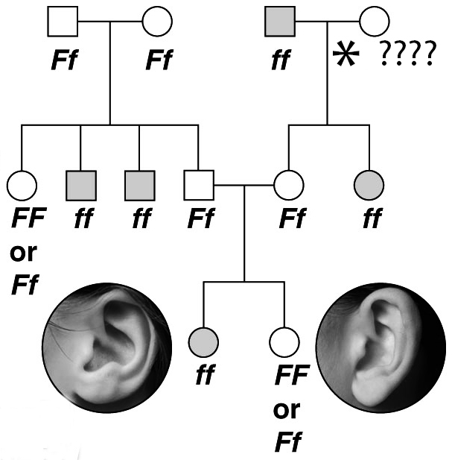

- FF
- Ff
- ff
- F
- Students must recognize that each person has two alleles, one inherited from each parent. Based on the genotypes of the offspring, one can determine the genotypes of the parents. This method was classically used to determine which individuals where carriers for genetic disorders.

Sample Course Outline:

Unit 1: The process of science and introductory chemistry
Chapters 1-5
Unit 2: Introduction to cells
Chapters 6-7
Unit 3: Energy in biological systems
Chapters 8-11
Unit 4: Cell division and inheritance
Chapters 12-15
Unit 5: Genes and gene expression
Chapters 16-8
Unit 6: Evolution
Chapters 22-25

