Course information:
-------------------
1. Course name: Anatomy & Physiology I
2. Department: BIO
3. Number: 221
4. Cluster requirement: Science of the Natural World
Faculty information:
--------------------
5. Name: Tara Rajaniemi
6. Email: trajaniemi@umassd.edu
7. Phone: 8223
Required components:
--------------------
8. Master syllabus: http:///webroots/www.umassd.edu/genedchecklist/holding/apimastersyllabus.doc
9. Course overview statement:
BIO 221/223 is a required course for nursing majors and is also taken by pre-professional biology majors. The lecture (BIO 221) and lab (BIO 223) together achieve the Cluster 2A learning objectives. The lecture is a systematic study of the human body, emphasizing structural and functional relationships. The lecture focuses on content knowledge, and so fulfills the first objective of understanding fundamental concepts in anatomy and physiology.
The lab combines experiments related to physiological processes and dissections for study of body structure. The experimental labs employ the scientific method, require students to gather and interpret quantitative data, and ask students to consider more complex problems using the knowledge gained through the activity. Thus, the lab fulfills the remaining Cluster 2A objectives.
Both the lecture and lab are required for nursing majors, and most students take the lecture and lab at the same time.
Material is presented to the students through assigned reading from a textbook, through face-to-face lectures, and through laboratory experiments and dissections. Student learning in the lecture is assessed through quizzes and exams. Learning in the laboratory is assessed through practical exams, quizzes, and lab write-ups.
10. Signed faculty and chair sponsor sheet: sent separately.
11. Official course catalog description for the course:
BIO 221 - Anatomy and Physiology I
3 credits
3 hours lecture
A systematic study of the human body emphasizing structural and functional relationships. Topics include cellular activity, histology, and organ system organization. The skin, skeletal, muscular, and nervous system morphology and function are presented.
BIO 223 - Anatomy and Physiology Laboratory I
1 credits
3 hours laboratory
Emphasis is placed on methods of measuring physiological processes. Study of body structure is accomplished by dissection of animal specimens and by use of tissue materials. 1 hour laboratory lecture, 2 hours laboratory


Master Syllabus
Course: BIO 221/223, Anatomy and Physiology I (Lecture and Lab)
Cluster Requirement: 2A, Science of the Natural World

This University Studies Master Syllabus serves as a guide and standard for all instructors teaching an approved in the University Studies program. Individual instructors have full academic freedom in teaching their courses, but as a condition of course approval, agree to focus on the outcomes listed below, to cover the identified material, to use these or comparable assignments as part of the course work, and to make available the agreed-upon artifacts for assessment of learning outcomes.

Course Overview:

BIO 221/223 is a required course for nursing majors and is also taken by pre-professional biology majors. The lecture (BIO 221) is a systematic study of the human body, emphasizing structural and functional relationships. The lab (BIO 223) combines experiments related to physiological processes and dissections for study of body structure. Student learning in the lecture is assessed through quizzes and exams. Learning in the laboratory is assessed through practical exams, quizzes, and lab write-ups. Both the lecture and lab are required for nursing majors, and most students take the lecture and lab at the same time. The lecture and lab together achieve the Cluster 2A learning objectives.

Learning Outcomes:

Course-Specific Learning Outcomes:
After completing the course, students will be able to:

University Studies Learning Outcomes: Cluster 2A, Science of the Natural World.
After completing the course, students will be able to:
1. Recount the fundamental concepts and methods in one or more specific fields of science.
2. Explain how the scientific method is used to produce knowledge.
3. Successfully use quantitative information to communicate their understanding of scientific knowledge.
4. Use appropriate scientific knowledge to solve problems.

Examples of Texts and/or Assigned Readings:

Human Anatomy and Physiology by Elaine N. Marieb (2010) 8th edition, Pearson/Benjamin Cummings Publishers
Human Anatomy & Physiology Custom Laboratory Manual, *Cat Version*, (2009), by Elaine N. Marieb
A Brief Atlas of the Human Body (2003) by Hutchinson, Mallatt and Marieb

Example Assignments:

The first Cluster 2A learning outcome (Recount the fundamental concepts and methods in one or more specific fields of science) is assessed in exams and quizzes in the lecture and the lab. Example questions are given here.

- Physiology may be defined as:
  - the study of the form of animals
  - the study of the form of any organism
  - the study of the functioning of an animal in its environment
  - the study of the functioning of any organisms in their environment

- The concept that states that the physiology depends on the anatomy is called ___.
  - complementarity
  - complexity
  - complimentation
  - competentarity

- A complex protein with tertiary structure is subjected to extreme heat. This causes the protein to unravel. This process is called:
  - decompensation
  - deflation
  - denaturation
  - devolution

- Which are the most abundant molecules in cell membranes?
  - carbohydrates
  - phospholipids
  - proteins
  - nucleotides

- In animal cells, the organelle called the ribosome is responsible for ___.
  - initial synthesis of proteins
  - maintaining cell structure and movement
  - energy production/ATP formation
  - controlling the cell

All four Cluster 2A learning outcomes are assessed in the write-ups of three labs (Enzyme Function, Cell Transport and Permeability, and EMG and Muscle Function). The student handout for one of these (Enzyme Function) is attached. Here, the link to each learning outcome is highlighted.

1. Recount the fundamental concepts and methods in one or more specific fields of science.
Question 2 requires students to recount fundamental concepts about enzymes.
2. Explain how the scientific method is used to produce knowledge.
Question 1 requires students to recognize that controlled experiments are used to understand processes that take place in the human body. In addition, students employ the scientific method of making observations, collecting data, and drawing conclusions in the lab as a whole.
3. Successfully use quantitative information to communicate their understanding of scientific knowledge.
Questions 3 and 4 require students to draw general conclusions from their data.
4. Use appropriate scientific knowledge to solve problems.
Questions 5 and 6 require students to apply knowledge from lecture and lab to explain alternative scenarios.

Sample Course Outline:

I. | Introduction: Nature of Science and the Scientific Method | Chap. 1
II. | Organic Molecules of Life | Chap. 2, 3
III. | The Cell
 | Cell Structure and Function | Chap. 4, 5, 9
 | Energy Pathways | Chap. 6, 7, 8
 | Cell Division: Mitosis & Meiosis | Chap. 9, 10
IV. | Advances in Cellular Biology | Chap. 15
V. | Molecular Basis of the Gene | Chap. 13, 14
 | DNA - Structure and Function
 | DNA, RNA and Proteins
VI. | Genetics | Chap. 11
VII. | Human Genetic Disorders | Chap. 12
VIII. | Advances in Molecular Genetics/DNA Technology | Chap. 15
IX. | Evolution: Historical Perspective | Chap. 16
X. | Evolution: Speciation | Chap. 17
XI. | Evidence of Evolution: Darwin’s Proof | Chap. 18

Enzyme Activity

INTRODUCTION
Virtually every chemical process that permits living organisms to survive and reproduce is dependent upon enzymes. Enzymes serve as biological catalysts - they cause biochemical reactions to proceed much more rapidly. For instance, the rate of hydrolysis of sucrose (where cane sugar is split into two monosaccharides, glucose and fructose) is approximately one trillion times greater when the enzyme invertase is present than when it is absent. The rates of most such reactions are so slow in the absence of enzymes that they simply are not compatible with life.
The substance (or substances) whose conversion is accelerated by the enzyme is termed the substrate. The enzyme aids in its conversion into one or more product(s). In the example given above sucrose is the substrate of invertase whereas fructose and glucose are the products of its action. Enzymes function by binding with substrate(s) to form an enzyme-substrate (E-S) complex. This complex then breaks down to yield the product and enzyme. Since the enzyme-substrate complex exists for a finite time, during which the enzyme is unavailable to react with other substrates, the reaction rate of enzyme-catalyzed reactions is usually directly dependent upon the amount of enzyme present.
Enzymes are not used up in the reactions in which they participate nor are they changed. However, since enzymes are proteins, they differ from most other catalysts in how they respond to variations in temperature and pH. Most chemical reactions occur more rapidly at high temperatures. Within the normal physiological range this is true of enzyme-catalyzed reactions as well, but at high temperatures the rates of enzyme-catalyzed reactions drop sharply. This is because enzymes, being proteins, lose their characteristic "shape" (become denatured) at high temperatures. Since the binding of enzyme to substrate is highly dependent upon enzyme shape, denaturation results in complete loss of catalytic activity. Enzyme activity is also highly susceptible to changes in pH. At extreme (acidic or alkaline) pH most enzymes are denatured and completely inactivated as they are at high temperatures. Within a more moderate range of pH values, enzyme activity usually shows a narrow pH optimum, above and below which activity rapidly declines. This may be due to the effect of pH on charged basic or acidic groups that commonly sit at the active site on the enzyme where the substrate binds. Alternatively, pH may affect charged groups on the substrate or it may affect the accessibility of the active site.
Proteins (most enzymes are proteins) are long molecules that fold up into particular shapes, usually fairly compact, and always the same folding shape for the same protein. The protein can only do its job (be active) when it is the right shape. Anything that changes its shape or causes it to unfold, such as excess heat or acid, makes it inactive. Therefore, many enzymes are heat-sensitive and can be damaged or destroyed by temperatures much above normal body temperature. Also, because proteins consist partly of charged chemical groups, their shapes are affected by charged ions in their environment, and therefore by pH, which is the measure of hydrogen (H+) ions. Each kind of enzyme has some pH at which it works best; this is called its optimum pH. As you might expect, the optimum pH of an enzyme usually matches the pH of the place where it's normally in use, whether that's the cytoplasm of a cell or a body fluid such as blood, saliva, or gastric juice.
When an enzyme (E) acts on one or more substrate(s), and changes it into the product(s). The reaction is usually written in this form:

S + E → ES → P + E

Why study this particular enzyme (catalase)?
A good enzyme to represent enzyme activity in general might be one which is important in living cells, easy to obtain, and whose product is easy to measure, so that reaction rates can be measured under different conditions. Catalase has these properties. Its function is to get rid of hydrogen peroxide (H₂O₂), a toxic product of certain reactions in cells. It catalyzes the reaction:

catalase
2 H₂O₂ → 2 H₂O + O₂↑

(Note: Which is the substrate of this reaction? The product(s)? The enzyme?)
The vertical arrow means that molecular oxygen is a gas and will rise out of solution. This makes the product easy to measure; we simply collect the gas and measure its volume.

MATERIALS & METHODS
The reaction will take place in an Erlenmeyer flask with a rubber stopper to prevent the oxygen produced from escaping into the air. An outlet tube in the stopper leads to an inverted burette (see Figure 2-1) which will be used to measure the volume of gas produced. The burette is filled with water and stands in a finger bowl of water. As gas is produced, the bubbles will rise in the burette and displace the water downward, giving a measure of the gas volume. Rubber tubing and a valve at the top of the burette allow the water level to be adjusted back to the zero line at the beginning of each run.

FIGURE 2-1

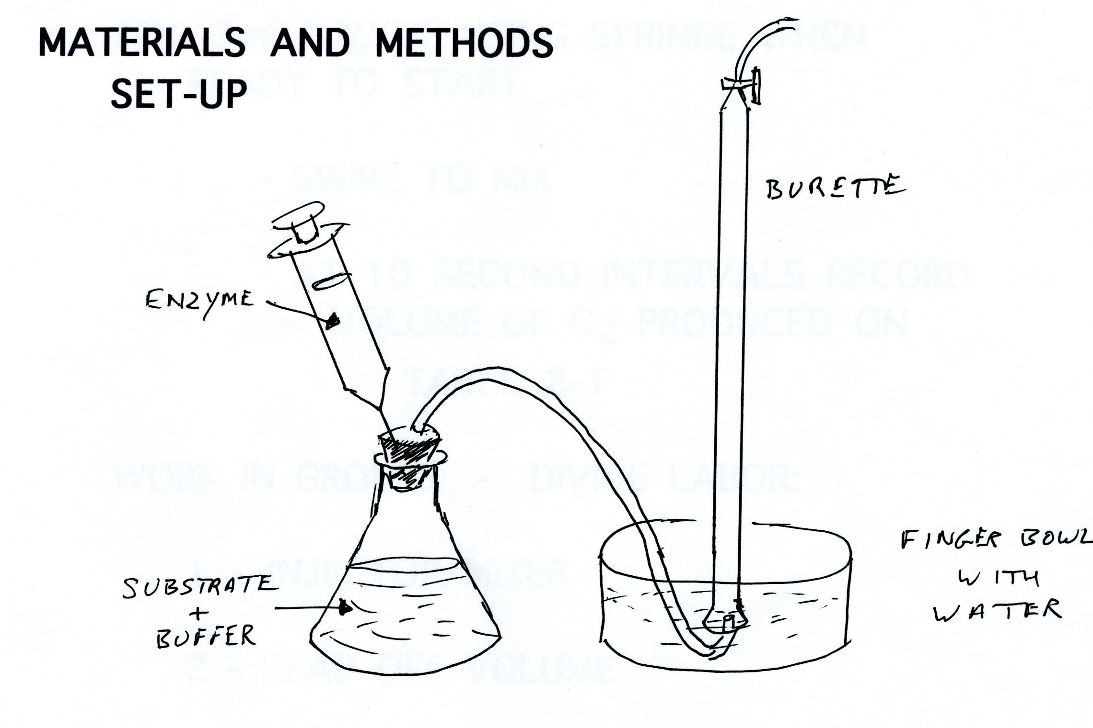

These solutions will be measured and mixed at the beginning of each run: The substrate (hydrogen peroxide), the enzyme (catalase); and a buffer solution. A buffer is a substance designed to maintain a constant pH. A pH7 buffer will be used for these experiments. The volume of the buffer solution will also be adjusted to make up the total reaction volume to 25 ml in each run.

Procedure:
General (for each run): Take great care that a pipette is only used for one solution. Rinse out the flask thoroughly before each run. Adjust the water level in the burette to zero; this is actually the line marked 100 ml, since the burette is inverted. Pipette the calculated amount of buffer into the flask. Pipette the calculated amount of peroxide into the flask. Mix by swirling. DON’T ADD ENZYME UNTIL YOU ARE READY TO START.
Fill the syringe with the calculated amount of enzyme. Attach the syringe to the needle in the rubber stopper and inject the enzyme carefully. Immediately swirl to mix, and continue swirling continuously at a uniform rate throughout the run. Every ten seconds take a reading of the water level in the burette and record it in the table 2-1 provided. (Note that you will have to convert the numbers read off burette to O2 produced since you are starting at 100 on the burette scale but really starting with 0ml O2.)

EFFECT OF VARYING SUBSTRATE CONCENTRATION
The volume of substrate (peroxide) will be varied. Remember that the total volume must always equal 25 ml so that smaller volumes of peroxide are balanced with larger volumes of buffer. For this section, you should continue to measure and record the level of oxygen in the burette every ten seconds for 3 minutes (or until production has nearly ceased). The volumes at 10 seconds and 40 seconds are particularly important since we will later use these values to calculate reaction rates.

Using the volumes of reagents given in the table below and following the general procedures described above, conduct five "runs" in which substrate is the variable.

SUBSTRATE ENZYME
RUN PEROXIDE pH 7 BUFFER (in syringe)

A1 (trial run) 6 ml 14 ml 5 ml

A2 4.5 ml 15.5 ml 5 ml
A3 3 ml 17 ml 5 ml
A4 1.5 ml 18.5 ml 5 ml
A5 (repeat of #1) 6 ml 14 ml 5 ml

RESULTS & DISCUSSION

TABLES
You should record the data from these experiments in the tables on the next two pages. Table 2-1 should show the cumulative amounts of oxygen (ml) produced over the duration of the experiments. Table 2-2 will show the rate at which O₂ is produced (ml O₂/sec.). The reaction rate in Table 2-2 is calculated by subtracting the volume of oxygen at 10 seconds from the volume at 40 seconds and dividing by 30.

GRAPHS: You should plot the following graphs (using graph paper).

Graph #1: Time (in seconds) vs. Cumulative oxygen production .
All 4 runs (A2-A5) should be plotted on the same graph. Volume at "0" time is 0 in all cases. Time is the independent variable and should go on the X axis. Cumulative Oxygen production goes on the Y axis. Use the data you collected in Table 2-1.

Graph #2: Substrate concentration vs. Rate of O₂ production (ml O₂/sec.)
In this graph use the data from Table 2-2 to plot the relationship between these two variables. In this graph, substrate concentration is the independent variable and therefore goes on the X axis.

QUESTIONS TO ANSWER:
(On a separate sheet of paper, please write out your answers to these questions using complete sentences.)

1. Why did we do this lab?
2. What role do enzymes play in normal body function?
3. Explain the variation in O₂ production over time with varying substrate concentrations. (Figure 2.1)
4. Explain how the RATE of O₂ production is affected by substrate concentration. (Figure 2.2)
5. What do you think might happen if you did these experiments using:
a. a buffer with a pH of 4?
b. a buffer with a pH of 10?
6. What do you think might happen if you did these experiments by adjusting the temperature:
a. to 45 degrees C?
b. to 10 degrees C?
NOTE: For comparison, room temp is ~23C and normal body temp is ~37C
Names of people in your lab group: ____________________________________________________

Table 2-1. Cumulative Oxygen Production (Part A)

Time after adding catalase (seconds)
RUN | 0 | 10 | 20 | 30 | 40 | 50 | 60 | 70 | 80 | 90 | 100 | 110 | 120
A1 (trial)
A2

A3

A4

A5

NOTE: Use the data from Experiments A2 to A5 above to create Figure 2.1

Table 2-2. Reaction Rates for Experiments A2 through A5

Experiments and Conditions | volume @ 10 seconds | volume @ 40 seconds | Rate (ml O₂ / second)
A2 (4.5 ml peroxide)
A3 (3 ml peroxide)
A4 (1.5 ml peroxide)
A5 (6 ml peroxide)

NOTE: Volumes can be transferred directly from Table 2.1. The Rate is calculated by subtracting the Volume O₂ produced by 10 sec from the Volume O₂ produced by 40 sec, then dividing by 30. Use the data for Rate and substrate concentration from the table above to create Figure 2.2

