Master Syllabus
Course: PHY 171, Planet Earth & its Resources I
Cluster Requirement: 2A, Science of the Natural World

This University Studies Master Syllabus serves as a guide and standard for all instructors teaching an approved in the University Studies program. Individual instructors have full academic freedom in teaching their courses, but as a condition of course approval, agree to focus on the outcomes listed below, to cover the identified material, to use these or comparable assignments as part of the course work, and to make available the agreed-upon artifacts for assessment of learning outcomes.

Course Overview:

An introduction to the earth sciences for the non-science major and anyone interested in the environment. Topics for the semester will include the origins and history of the earth, plate tectonics, igneous activity, glacial history and landforms, geologic history, and earlier environments and life forms on the earth. Supplemental class exercises will also be assigned periodically and may be completed individually or within groups.

Most recent instructor: Mr. John Silva, II – 203B, x8354, jsilva@umassd.edu.

Learning Outcomes:

Course-Specific Learning Outcomes:

After completing this course, students will have gained:

• General understanding of geology and the process used to accumulate geological information.

• General comprehension of the extended time frames required for most geological processes, such as fossilization, to unfold.

• General comprehension of how other sciences contribute to an understanding of the geological topics being discussed

University Studies Learning Outcomes:

After completing this course, students will be able to:

1. Recount the fundamental concepts and methods in one or more specific fields of science (here, geology, including the catastrophic effects of earthquakes, volcanic eruptions, etc.).
2. Explain how the scientific method is used to produce knowledge, including the critical capacity to separate movie fiction from scientifically tested fact.
3. Successfully use quantitative information to communicate their understanding of scientific knowledge, such as how scientific data is used to predict future environmental scenarios.
4. Use appropriate scientific knowledge to solve problems.

Examples of Texts and/or Assigned Readings:

A text is not required for this course. For those wishing some sort of a printed resource, Mr. Silva recommends the following: Earth Science, Tarbuck and Lutgens, editions 10, 11, or 12, Prentice Hall/Pearson. Also see Appendix A below.

Outcomes Mapping

The sample assignment found below addresses all of the Cluster 2A Outcomes 1, 2, 3, and 4:

1. Recount the fundamental concepts and methods in one or more specific fields of science.
2. Explain how the scientific method is used to produce knowledge, including the critical capacity to separate movie fiction from scientifically tested fact.
3. Successfully use quantitative information to communicate their understanding of scientific knowledge, such as how scientific data is used to predict future environmental scenarios.
4. Use appropriate scientific knowledge to solve problems.

In preparation for this assignment, students will have been exposed to the general principles of stratigraphy and the processes required for the formation of sandstones, slates, limestones, and plutonic structures. This assignment is also part of the next scheduled exam.
Similar in-class assignments are conducted on a range of subjects in the curriculum. (See Sample Course Outline below.) And like all class assignments, the sample assignment requires 100% accuracy. Partial credit is not allowed for any answer. Simply put, its either all right or all wrong.

Class Syllabus:

PHY 171 Planet Earth One

Week 1: Chapter 5 The Active Earth: Plate Tectonics

Topics include:
Continental Drift
Alfred Wegener
Proofs for Continental Drift
Types of Plate Boundaries
Ridge systems
Sea floor spreading
Hot spots
Sub-surface convection
Ring of Fire

Weeks 2 and 3: Chapter 7 Volcanoes and Igneous Activity
Topics include:
Types of volcanic cones
Magma composition
Lava composition
Flood basalts
Caldera formation
Plinian eruptions
Hydrothermal events
Vulcanian eruptions
Hawaiian eruptions
Strombolian eruptions
Pahoehoe formations
AA formations
Pillow lavas
Lunar basalts
Lunar volcanoes
Martian volcanic cones

Week 4: Completion of chapters 5 and 7

Week 4: Exam 1

Week 4: Chapter 6 Earthquakes and the Earth's Structure

Topics include:
P waves
S waves
L waves
Amplitude
Magnitude
Intensity
Focus
Epicenter
EQ probabilities
1907 SF quake

Week 5: Chapter 11 Glaciers and the Ice Ages

Topics include:
Pleistocene glaciation
Holocene glaciation
Continental glaciation
Valley glaciers
Mountain glaciers
Erratics
Kames
Drumlins
Moraine formations
Till
Melt water streams
Kettles
Kettle ponds
Kettle lakes
Origin of the Great lakes
Formation of Cape Cod
Glacial formations on UMass campus

Week 6: Exam 2

Week 7: Chapter 4 Geologic Time: A Story in the Rocks

Topics include:

Geomorphology basics
Stratification
Original horizontality
Order of events
Cross cutting
Erosion
Tilting
Anticlines
Synclines
Igneous intrusions

Week 8: Chapter 4 Geologic Time: Stratigraphy, Correlation, Faunal Succession

Topics include:
Correlation problems
Faunal succession
Types of fossil formation
Psuedo-fossils
Trace fossils

Week 9: Completion of chapter 4

Week 10: Exam 3

Week 11, 12, 13 Geologic History: An Introduction to Paleontology

Topics include:
Mass extinctions
Cambrian extinction
Ordovician extinction
Devonian extinction
Permian extinction
Cretaceous extinction
P/T boundary
K/T boundary
Chicxulub crater
Asteroid belt

Week 14: Final Exam

Note: The dates listed above are an approximation and may be altered due to weather or scheduling considerations.

Note: It requires a minimum of one hour, or one complete class meeting, to present the basis for solving stratigraphic profile problems. This is also one of the problems in which I generally prefer students share their respective efforts. Students can generally expect to need two to three hours to complete the ten problem set that appears below. The average number of correct responses per student is generally three or four of ten.

Sample Stratigraphy Assignment

The assignment that appears below involves the introductory steps of understanding the methodology, reasoning, and mathematical related problem solving of stratigraphy. In its introductory form, it does not require needless and meaningless mathematical formulas and calculations or the analysis of the chemistry of the rock or mineral involved. What it does entail is both inductive and intuitive reasoning, an attention to the smallest of details, and the analytical skill of a mathematics problem.

To complete this assignment, you must complete each of the ten problems with 100% accuracy. Partial credit will not be allowed. All responses must appear in a column format and be appropriately numbered. For problem nine and ten, you will provide the appropriate illustration to match the sequence that appears to next to the illustration box. All illustrations must be numbered or lettered and reference the problem.

The sample assignment found below addresses all of the Cluster 2A Outcomes 1, 2, 3, and 4:

- Recount the fundamental concepts and methods in one or more specific fields of science.
(Obviously necessary if a one hour session is required to explain the terminology)

2. Explain how the scientific method is used to produce knowledge, including the
critical capacity to separate movie fiction from scientifically tested fact.

(I have no idea why the second half of this question exists or even who authored
it. It doesn’t deserve a response because the answer is obvious. However, the
initial half of the question is valid and it should be obvious that this is a
problem solving exercise that distinctly relies upon mathematical style analysis
combined with a fundamental understanding of stratigraghic principles. You
apply an understanding of superposition and fold scenarios to formulate a
reasonable scenario for the events to occur. If you don’t understand analysis or
the basic fundamentals, you CANNOT complete a problem successfully.)

3. Successfully use quantitative information to communicate their understanding
of scientific knowledge, such as how scientific data is used to predict future
environmental scenarios.

(Successfully completing the problems indicates that someone is fully
aware that the past repeats itself. Present rock layers will distort, fold, tilt,
and alter to some degree in the future. The past is the present and the
present is the past. The results derived from each problem predict the future
allow a student to construct a general stratification history for any
complicated strata. The Grand Canyon is a prime example.)

4. Use appropriate scientific knowledge to solve problems.

(Since this sets of problems is dependant an understanding of the principles
of stratigraphy, the classroom exposure is necessary. It is one of the few
times that a student will use factual data, the lecture, and combine it with
intuitive and analytical skills.)

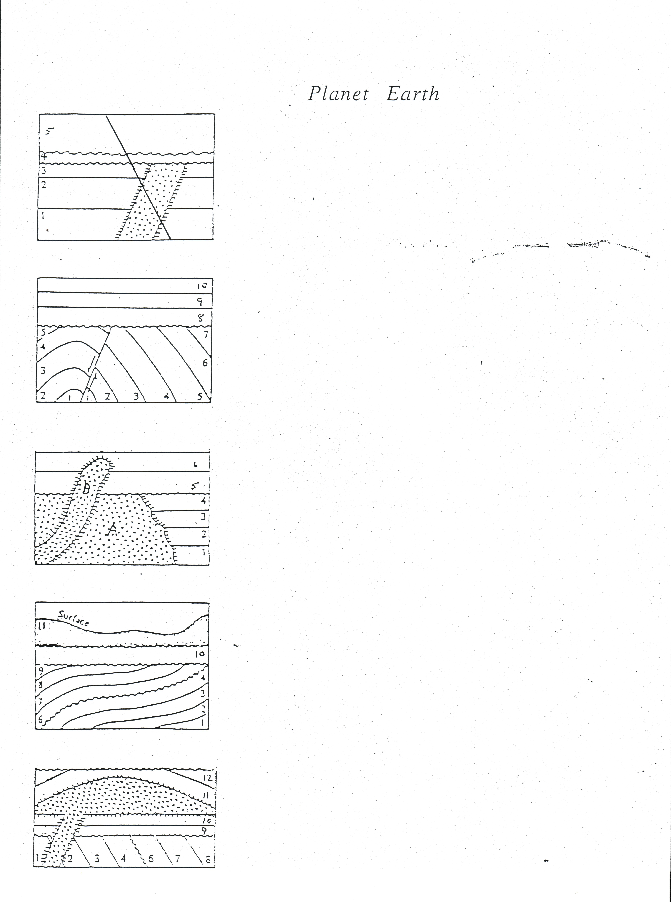

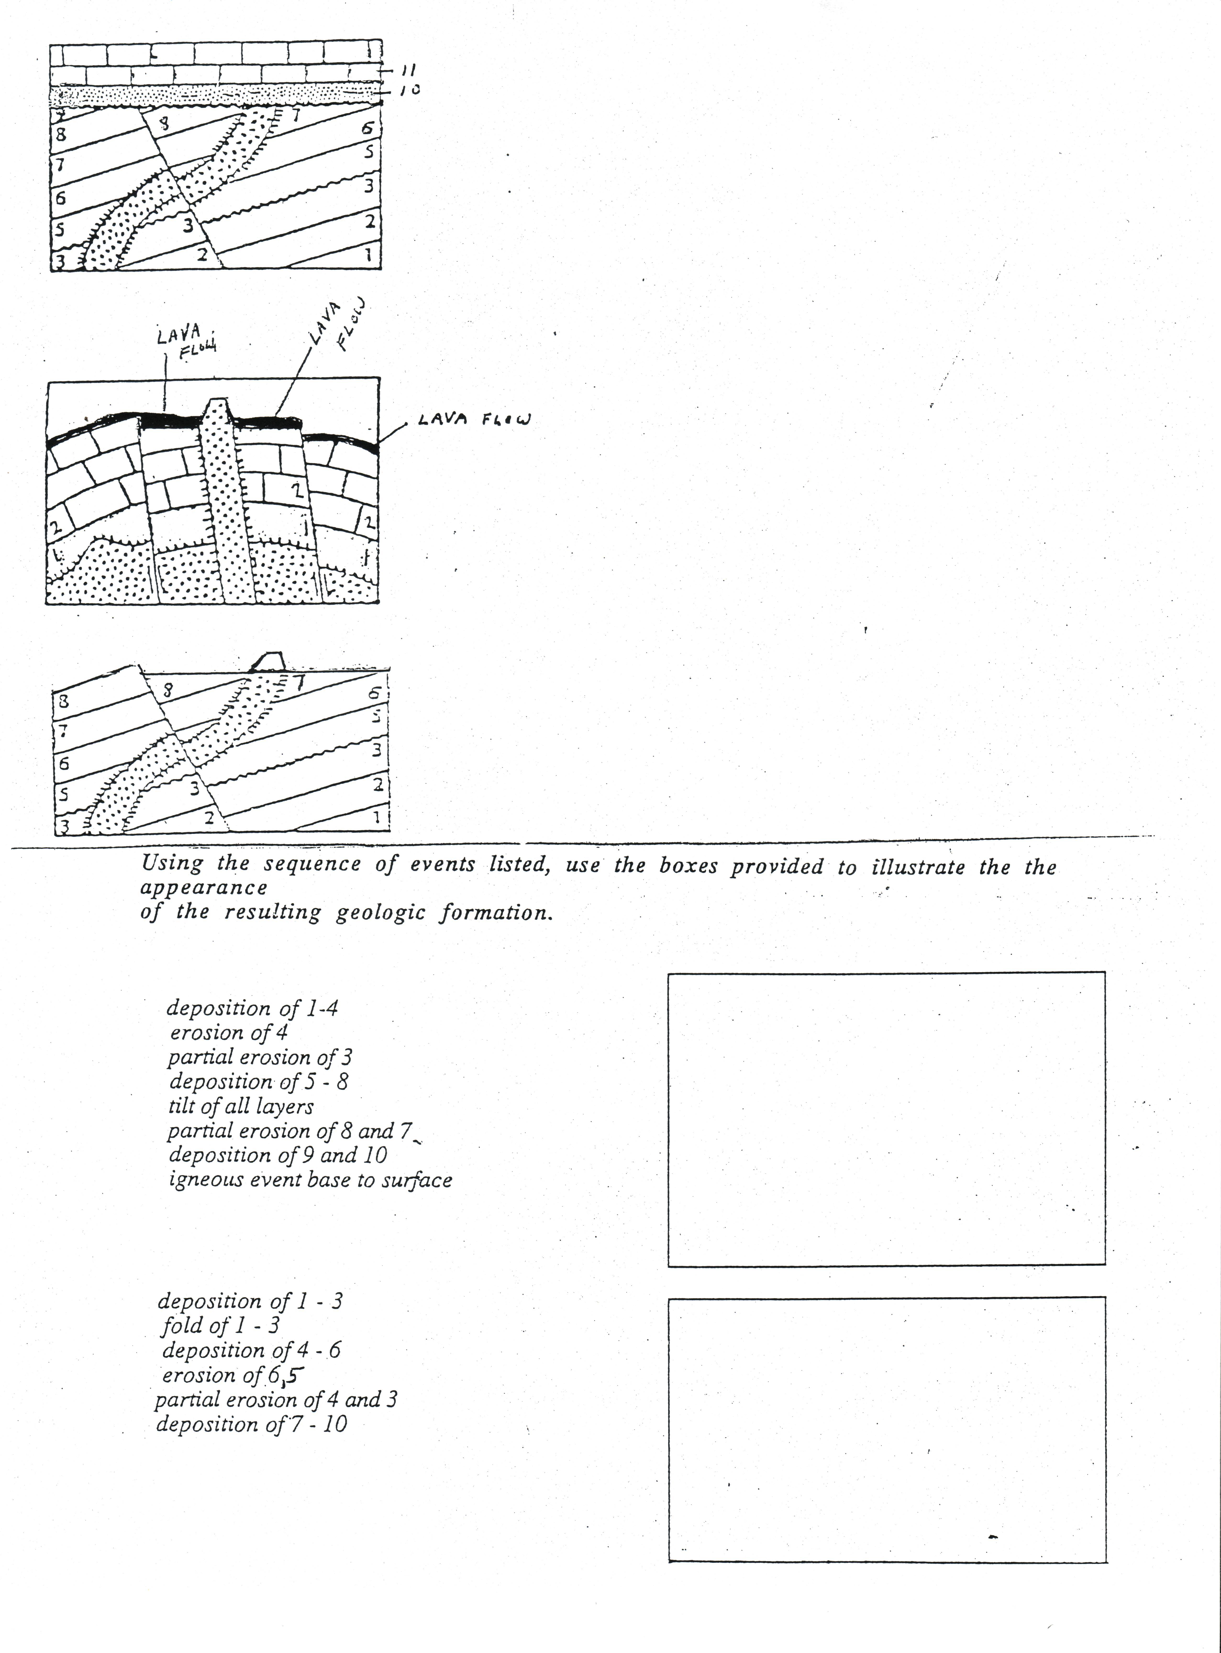
Sample solution for problem five or last problem of first side or section.

Deposition of layer 1
Deposition of layer 2
Deposition of layer 3
Deposition of layer 4
Deposition of layer 5
Erosion of layer 5
Partial erosion of layer 4
Deposition of layer 6
Deposition of layer 7
Deposition of layer 8
Tilt of layers 1- 4 and 5 – 8
Partial erosion of layers 1 – 4 and 5 – 8
Deposition of layer of 9
Deposition of layer of 10
Deposition of layer 11
Deposition of layer 12
Igneous intrusion (laccolith) thru layers 1 and 2 and 9 and 10
Fold of layers 11 and 12
Partial erosion of layer 12
Partial erosion of layer 11

