Course information:
-------------------
1. Course name: Intermediate astrophysics
2. Department: Physics
3. Number: 251
4. Cluster requirement: Science of the Natural World

Faculty information:
--------------------
5. Name: Alan Hirshfeld
6. Email: ahirshfeld@umassd.edu
7. Phone: 8715

Required components:
--------------------
8. Master syllabus: http:///webroots/www.umassd.edu/genedchecklist/holding/us_phy251syllabus.doc
9. Course overview statement:
University Studies Course Rationale

PHY 251, Intermediate Astronomy

PHY 251, Intermediate Astronomy, covers the physics of the Sun and stars – their properties, energy-making processes, formation, and life histories. The course is designed for non-science majors with no prior experience in astronomy. Lectures, exams, and class assignments involve the use of basic mathematics, including scientific notation, algebra, geometry, and simple trigonometry. Most class periods are divided into two parts: an illustrated lecture-demonstration, lasting approximately 30 minutes and covering relevant topics in astronomy, followed by a team-based instructional activity. Completed activities are submitted at the end of the class period for grading. The activities are designed to illustrate how basic physical principles and astronomical observations can be applied to compute such things as the energy output of the sun, the solar energy intercepted by the earth, the lifetimes of the sun and the stars, the dynamics of stellar explosions, the rotational prope
rties of the galaxy, etc. By doing such calculations themselves, students gain a meaningful sense of the kind of work that scientists do. Weather permitting, students are encouraged to attend evening viewing sessions at the campus observatory; dates and times will be announced.
PHY 251 is structured to help students fulfill the Cluster 2A science learning outcomes; upon successful completion of the course, they will be able to:

• Recount the fundamental concepts and methods in one or more specific fields of science (here, astronomy and physics).
• Explain how the scientific method is used to produce knowledge.
• Successfully use quantitative information to communicate their understanding of scientific knowledge.
• Use appropriate scientific knowledge to solve problems.

Assessment of these learning outcomes is conducted throughout the semester, by direct faculty interaction with individual students as they work through the in-class activities, and by monitoring grades on these activities, quizzes, and tests.

10. Signed faculty and chair sponsor sheet: sent separately.
11. Official course catalog description for the course:
PHY 251 - Intermediate Astronomy
3 credits
Prerequisites: PHY 151 or permission of instructor
Underlying physical processes that determine the appearance and behavior of astronomical objects, such as planets, stars, galaxies, and the universe itself will be emphasized. The technology of modern astronomical observation will also be discussed. Simple mathematics, including algebra and power-of-ten notation, will be used. Observations of celestial objects will be made at the university observatory. A follow-up of PHY 151, this course is designed for non-science majors who wish to explore selected topics in astronomy in greater detail.

Master Syllabus
Course: PHY 251, Intermediate Astronomy
Cluster Requirement: 2A, Science of the Natural World

This University Studies Master Syllabus serves as a guide and standard for all instructors teaching an approved in the University Studies program. Individual instructors have full academic freedom in teaching their courses, but as a condition of course approval, agree to focus on the outcomes listed below, to cover the identified material, to use these or comparable assignments as part of the course work, and to make available the agreed-upon artifacts for assessment of learning outcomes.

Course Overview:

Astronomy is the scientific study of the universe, its contents, and its physical processes. PHY 251, Intermediate Astronomy, covers the physics of the Sun and stars – their properties, energy-making processes, formation, and life histories. The course is designed for non-science majors with no prior experience in astronomy. Lectures, exams, and class assignments will involve the use of basic mathematics, including scientific notation, algebra, geometry, and simple trigonometry. Most class periods are divided into two parts: an illustrated lecture-demonstration, lasting approximately 30 minutes and covering relevant topics in astronomy, followed by a team-based instructional activity. Completed activities are submitted at the end of the class period for grading. Weather permitting, students are encouraged to attend evening viewing sessions at the campus observatory; dates and times will be announced.

Learning Outcomes:

Course-Specific Learning Outcomes:

By the end of the semester, in addition to practice in critical thinking and quantitative reasoning, you should have gained:

• an appreciation of the historical path by which astronomers have accumulated knowledge about stars.
• an understanding of the physical properties of stars (including the Sun) and how astronomers obtain this information through observation.
• an understanding of the basic physics of stars, including both ordinary and unusual stars, such as white dwarfs, supernovae, pulsars, neutron stars, and black holes.
• a knowledge of the Sun’s structure and evolution.
• a knowledge of crucial astronomical quantities and physical laws.
• an understanding that the same physical laws and processes are valid everywhere in the Universe.
• an understanding of the roles of observations, experiments, theory and mathematical models in science.
• a realization that uncertainty is inevitable in science, but that this does not mean that a given scientific theory is wrong.
• some knowledge of related subjects, such as physics and mathematics.

University Studies Learning Outcomes:

After completing this course, students will be able to:

• Recount the fundamental concepts and methods in one or more specific fields of science.
• Explain how the scientific method is used to produce knowledge.
• Successfully use quantitative information to communicate their understanding of scientific knowledge.
• Use appropriate scientific knowledge to solve problems.

Examples of Texts and/or Assigned Readings:

• Strobel, Nick, Astronomy Notes. www.astronomynotes.com (free online).
• Instructor-authored class notes.

Example Assignments:

OUTCOMES MAPPING: Each of the following example assignments addresses Cluster 2A Outcomes 1, 2, 3, and 4: through their answers to the assignments, students master specific scientific concepts, and use the scientific method and quantitative reasoning to solve scientific problems and communicate their knowledge of the subject material. An answer key and grading rubric are appended to each assignment below. There are approximately a dozen such in-class assignments altogether covering a broad range of topics in solar and stellar astronomy. The instructor is present to answer students’ questions as they work through each assignment. There are also three tests and several quizzes during the semester.

PHY 251, Intermediate Astronomy Spring 2012

ACTIVITY 3: The Solar Constant

One of the key attributes of the Sun, besides its size and mass, is its luminosity L – the total amount of energy the Sun emits per second in all directions. This energy comprises a broad spectrum of wavelengths from the ultraviolet through the visible and into the infrared. There are even relatively small amounts of X-rays and radio waves. How can we measure the Sun’s overall energy output? Not only are we very far from the Sun’s surface, but all that we ever see of the Sun’s total luminosity is the tiny fraction that washes over the Earth. However, measuring the solar rays that illuminate Earth provides a starting point to compute the Sun’s total energy output; after that, it’s just geometry. Therefore, we will try to measure the overall intensity of sunlight at the Earth, expressed as the solar constant S.
Sun
Earth

Basic Concepts

1. The intensity of sunlight has been carefully measured for many years by detectors on the ground and on satellites that orbit our Earth. Measurements made by detectors in space are much preferred to those made by detectors on Earth’s surface. Why do you think that is? Be specific.

2. To correctly measure the intensity of sunlight at the Earth, a satellite must be positioned the same distance from the Sun as is Earth. Obviously, a satellite circling, say, 200 kilometers above Earth’s surface might be as much as 200 kilometers closer to the Sun or 200 kilometers farther from the Sun than is Earth, depending on where the satellite is situated along its orbital path. Given that Earth’s average distance from the Sun is about 150 million kilometers, do you think a variation of 200 kilometers matters to a measurement of the Sun’s intensity? Support your answer by computing what fraction 200 kilometers is of the Earth-Sun distance.

Measuring the Solar Constant

The attached graph shows the measured distribution of solar energy over a wide range of wavelengths. The graph’s horizontal axis indicates the wavelength of the energy in units of nanometers. (A nanometer, abbreviated nm, is a billionth of a meter: 10⁻⁹ meter.) Wavelengths visible to the human eye – the optical portion of the spectrum – fall within the range of about 350 nm (violet) to 700 nm (red).

3. On the graph’s wavelength axis, draw marks to indicate the range of the optical portion of the Sun’s spectrum. If the eventual goal is to compute the Sun’s overall luminosity L, why is it necessary to measure the Sun’s emission with detectors that are sensitive to both optical and non-optical wavelengths?

The vertical axis of the attached graph is the intensity of the Sun’s light expressed in units of watts per square meter per nanometer, abbreviated W/m²/nm. There are three components to this rather cumbersome unit:

• The number of watts (W) indicates the rate at which energy is emitted, whether for the Sun or for a household light bulb. That is, a 100 watt light bulb will emit more energy each second than a 60 watt bulb, and will therefore appear brighter.

• The Sun’s emission shines in all directions. However, let’s focus exclusively on the solar wattage shining on a make-believe light sensor whose shape is a square, one meter on a side. That’s what the term per square meter refers to in the graph’s vertical-axis unit. That is, we’re sampling only the sunlight that shines onto a one-square-meter detector and ignoring the rest.

• The third part of the vertical-axis unit, per nanometer (nm) indicates that the numbers along the vertical axis refer to the sunlight intensity measured within very narrow wavelength segments, each just 1 nanometer wide. For example, the Sun gives out less energy at a wavelength of 300 nm (ultraviolet) than at 700 nm (red): about 0.45 W/m²/nm compared to 1.4 W/m²/nm.

To determine the solar constant S – the overall intensity of sunlight falling on a 1-meter square at Earth – we must sum up the various amounts received at all of the individual wavelengths. This is easily done using the graph. In fact, the area of the graph underneath the solar intensity curve represents precisely what we are seeking: the solar constant S, in units of watts per square meter (W/m²). To ease the determination of the area underneath the intensity curve, the graph has been divided into small boxes. Counting these boxes is the first step to achieve a value for the area.

4. Count the number of boxes underneath the solar intensity curve in the graph. For boxes that are divided by the curve itself, you might adopt the following procedure: Estimate what fraction of the box lies underneath the curve. If the fraction underneath the curve is less than one-half, omit that box from the count; if the fraction is greater Than one-half, include the box in the count.

5. All we have determined so far is the number of boxes that lie underneath the solar intensity curve. However, the area of each box represents a specific amount of solar energy that can be estimated from the graph’s horizontal and vertical axes. (a) What is the width of each box, in nanometers, according to the graph’s horizontal axis? (b) What is the height of each box, in watts per square meter per nanometer, according to the graph’s vertical axis? (c) Remember, for a rectangular box, area equals width times height. Therefore, multiply together your answers to parts (a) and (b) to yield the area of a box, in watts per square meter. That is, each box in your count from part 4 represents this amount of solar energy.

6. Multiply your answer to part 5(c) by your count of boxes underneath the solar intensity curve from part 4. The resulting number is your estimation of the solar constant S, the total amount of solar energy at all wavelengths received at Earth. (Quick check: The standard value of S is about 1370 W/m²; if your answer differs substantially from this number, review your work for errors.)

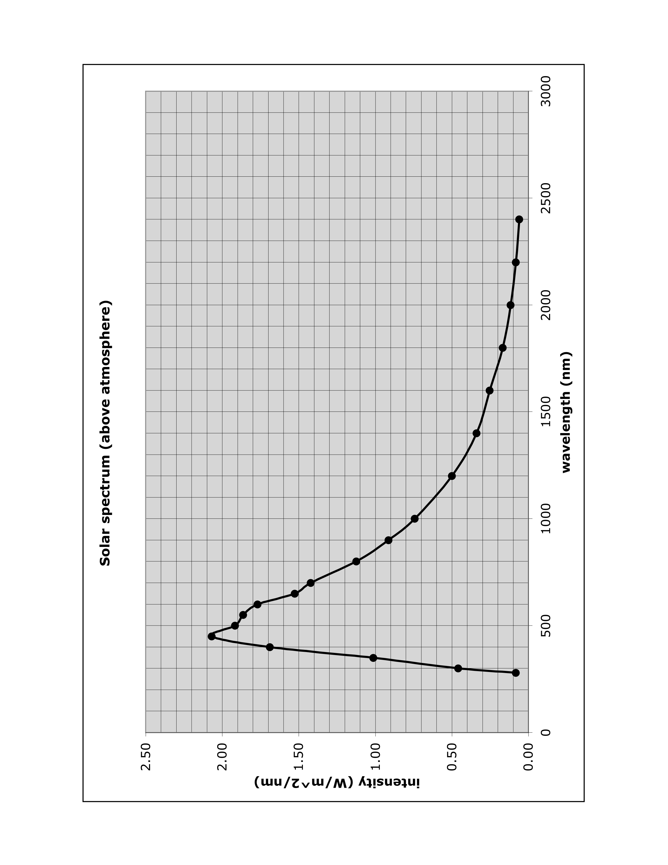
PHY 251, Worksheet, Activity 3: The Solar Constant

NAME _____________________________________ SHOW YOUR WORK.

1. Answer: space-based measurements are not affected by the atmosphere. The atmosphere distorts and absorbs energy, hence, one needs all wavelengths of observation.

2. Answer: a variation of 200 km is insignificant compared to the distance of the sun; therefore, it has no discernible impact on the sun's measured intensity.

3. Answer: the sun in its substantial energy at non-optical wavelengths. These must be included in the calculations.

4. Number of boxes = ___________________ [answer: approximately 130]

5. (a) Width of box = ________________________ nanometers [answer: approximately 100]

(b) Height of box = _______________________ watts per square meter per nanometer [answer: approximately 0.1]

(c) Area of box = _________________________ watts per square meter [answer: approximately 10]

6. Solar constant S = _____________________ watts per square meter (W/m²) [answer: approximately 1400]

Grading rubric: a student's score is determined by the percentage of correct answers and the clarity of written responses.

PHY 251, Intermediate Astronomy Spring 2012

ACTIVITY 4: The Luminosity of the Sun

Now that we’ve figured out the solar constant S, the amount of solar energy striking a one-meter square at Earth each second, it’s straightforward to compute the Sun’s luminosity L, the overall amount of energy the Sun emits per second. But first a brief detour.

An Earth’s Worth of Solar Energy

With the information gained in the previous activity – the solar constant S – it’s possible to figure out how much solar energy is intercepted by the entire Earth. The solar constant S is the solar energy illuminating a 1-meter square situated at Earth’s distance from the Sun. Imagine placing a second 1-meter square alongside the first square; together these squares intercept twice the energy of the single square, that is, 2 x S . Adding a third 1-meter square raises the collective solar energy to 3 x S . For 4 such squares, the total solar energy is 4 x S , and so on. Now imagine assembling an immense number N of these squares, enough to cover a circular disk as wide as the Earth itself. (Sure, the corners of some squares will stick out beyond the disk’s circular border, but that has minimal effect on our estimation.) The energy striking this big disk – numerically, N x S – is equivalent the solar illumination over our entire planet each second.

The number N is easy to calculate: it is the number of 1-meter squares required to assemble an Earth-sized disk, or equivalently, it is the area A of a circular disk whose radius is equal to Earth’s. The area of a circular disk is given by the formula A = πR² , where R is the disk’s radius. In this case, R = 6.378 x 10⁶ meters, the radius of Earth.

1. Using the area formula, compute the area A of an Earth-size disk. Since the answer is expressed in units of square meters, it is equivalent to the number N described above.

2. To find the total solar illumination on Earth per second, multiply the accepted value of the solar constant S (1370 W/m²) by your answer for N in part 1, that is, compute N x S . Your answer will come out in units of watts.

3. How many times larger is the total solar illumination on Earth than (a) the collective energy generation rate of all the world’s nuclear power plants: 4 x 10¹¹ watts; and (b) the average energy consumption rate for the entire United States: 3.4 x 10¹² watts. (Note: These numbers represent the average energy generation or energy consumption per second!)

The Sun’s Luminosity

Now back to the task at hand: measuring Sun’s luminosity L, the overall amount of energy it emits. To solve the problem, we add yet more 1-meter squares to the Earth-sized disk we already created above. We gently curve this growing disk inward so that it increasingly envelops the Sun. Ultimately, we will have built an enormous sphere that completely surrounds the Sun. Any light energy leaving the Sun’s surface must necessarily strike this sphere on its way to deep space. (Let’s ignore the miniscule fraction of solar energy intercepted by the inner planets Mercury and Venus.)

To find the Sun’s luminosity L, we follow the previous procedure, but instead of computing the solar energy swept up by Earth, we compute the solar energy illuminating the Sun-concentric sphere we just created. That means multiplying the solar constant S by the surface area A of the sphere whose radius is equal to the radius of Earth’s orbit, 1 AU, as shown in the figure. (Don’t confuse the radius of Earth itself with the radius of its orbit, which is more than 20,000 times larger.)
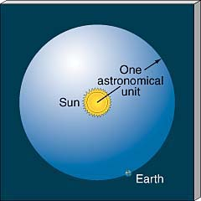
4. The surface area A of a sphere is given by the formula A = 4πR² , where R is the sphere’s radius. In this case, R = 1 AU = 1.50 x 10¹¹ meters, the average radius of Earth’s orbit (here expressed in meters instead of the usual kilometers). Using the area formula, compute the area A of the Sun-concentric sphere described above.

5. To find the Sun’s luminosity L, multiply the solar constant S by your answer for A in part 4. Your answer for L will again come out in units of watts. (Quick check: The accepted value of L is about 3.84 x 10²⁶ W; if your answer differs substantially from this standard value, review your work for errors.)

As far as luminosity goes, the Sun is no champion. The red supergiant star Betelgeuse shines with a luminosity of ten-thousand Suns. There are even a few stars whose luminosity exceeds a million Suns!
PHY 251, Worksheet, Activity 4: The Luminosity of the Sun

NAME _____________________________________ SHOW YOUR WORK.

1. Area A of Earth-size disk = _______________________________ square meters [answer: 1.28 x 10^14]

2. Total solar illumination on Earth per second = __________________________ watts [answer: 1.7 x 10^17]

3. (a) ______________________________________ [answer: approximately 400,000]

(b) ______________________________________ [answer: approximately 50,000]

4. Surface area A of Sun-concentric sphere = _____________________________ square meters [answer: 2.8 x 10^23]

5. Sun’s luminosity L = _______________________________________ watts [answer: 3.8 x 10^26]

Grading rubric: a student's score is determined by the percentage of correct answers and the clarity of written responses.

Sample Course Outline:

II
PHY 251, INTERMEDIATE ASTRONOMY, SPRING 2012
SYLLABUS

If you want to make an apple pie from scratch, you must first create the universe. – Carl Sagan

Description: PHY 251, Intermediate Astronomy, covers the physics of the Sun and stars – their properties, energy-making processes, formation, and life histories.

Instructor: Prof. Alan Hirshfeld Office: Group II-208B (enter from the atrium off the main hallway)
Phone: 508-999-8715 or extension 8715 from an on-campus phone
E-mail: ahirshfeld@umassd.edu (This is the surest way to get in touch with me outside of class.)
Office Hours: T/Th 10:00-11:00, 12:30-2:00, or after 5:15 pm by appointment.

Prerequisites: PHY 251 is a follow-up to PHY 151, Introductory Astronomy. However, there is limited overlap between the courses; any necessary background material from PHY 151 will be re-introduced here. Lectures, exams, and class assignments will involve the use of basic mathematics, including scientific notation, algebra, geometry, and simple trigonometry. Mathematics tutorials are available upon request – just ask me.

Required Materials: Strobel, Astronomy Notes, web-text at www.astronomynotes.com (free online).
Any basic scientific calculator (must have trigonometry keys SIN, COS, and TAN).

Reading Assignments: I will announce the reading assignments in the Strobel web-text as we proceed through the topics. I will also periodically email you lecture notes that you can use as a guide to what we are covering in class. The readings and notes provide the fundamental vocabulary, definitions and general information; lectures provide further explanation and context of the material. Feel free to ask questions during or outside of lecture about any reading material you don’t understand.

Class Attendance: Because of the format of this course, with its emphasis on in-class work, class attendance is required. Frequent absences will pull down your grade.

In-Class Work:
• Whenever possible, class periods are divided into two parts: lecture/discussion and team-based activity time. Instructions for the day’s activity will be distributed in class. The activity must be completed and turned in before the end of that class. However, if you are not done, you may ask me for an extension. Otherwise, late activities are graded as a zero.
• If you do not understand any part of an activity, feel free to ask me for help.
• There are no make-ups for missed in-class activities or quizzes for any reason; however, you are permitted to miss ONE activity and ONE quiz during the semester without penalty. After these “freebies,” each missed quiz or activity counts as a zero. Do not ask for exceptions to this policy!
• If you miss an activity, you should complete it anyway on your own (with my help, if you need it). General concepts from the activities will appear on the tests.
• Use of laptops, cell phones, or other electronic devices is prohibited in the classroom. It’s distracting to me and to your fellow students.

Exams: There will be 3 tests during the semester on the dates indicated on the schedule below. The tests will be based on material covered in the lectures, reading assignments, and in-class work. Most of the test questions go beyond mere memorization of facts and are designed to test your conceptual understanding of astronomy and the underlying science. Missed tests must be made up within 1 week by individual arrangement with me; after that, a zero is assigned for the test. Approximately 3 quizzes will be given, some without prior notice. There is no final exam.

Grades: Your grade for the course will be based on your overall score, which is computed from the following components: each of the three tests counts as 20% of the overall score; quizzes and homework as 20%; and in-class activities as 20%. Your semester grade will be based on your overall score, according to the following breakdown: A 90-100; B 80-89; C 70-79; D 60-69; F less than 60. For example, if you score 80 on each of the three tests, 90 on the quizzes/homework, and 90 on in-class activities, your average score is: .20(80) + .20(80) + .20(80) + .20(90) + .20(90) = 84, a grade of B. Your semester grade, as determined from this formula, will be lowered for poor attendance, that is, if you miss too many in-class activities during the semester. Your semester grade will be raised if you frequently participate by asking or answering relevant questions in class. With the exception of occasional extra assignments at the instructor’s discretion, NO INDIVIDUAL EXTRA CREDIT WORK IS AVAILABLE.

Computer Requirement: Announcements and notes will be distributed by e-mail to your on-campus email address only. If you use an off-campus email address, it is your responsibility to arrange with Academic Computing Services (ACS) to have your campus email forwarded to your alternate address.

Evening Viewing Sessions: Weather permitting, you are invited to attend one or more of the evening viewing sessions at the campus observatory throughout the semester. Dates and times will be announced.

How to Do Well in this Course: Here is my advice, based on years of experience:
• Come to class. Pay attention.
• Complete all in-class activities.
• Ask questions if you don’t understand something.
• Keep up with the reading assignments.
• Don’t leave test studying to the last minute.
• Come see me or contact me if you are having trouble understanding the material. I am glad to help!

Educational Goals of this Course: By the end of the semester, in addition to practice in critical thinking and quantitative reasoning, you should have gained:

• an appreciation of the historical path by which astronomers have accumulated knowledge about stars.
• an understanding of the physical properties of stars (including the Sun) and how astronomers obtain this information through observation.
• an understanding of the basic physics of stars, including both ordinary and unusual stars, such as white dwarfs, supernovae, pulsars, neutron stars, and black holes.
• a knowledge of the Sun’s structure and evolution.
• a knowledge of crucial astronomical quantities and physical laws.
• an understanding that the same physical laws and processes are valid everywhere in the Universe.
• an understanding of the roles of observations, experiments, theory and mathematical models in science.
• a realization that uncertainty is inevitable in science, but that this does not mean that a given scientific theory is wrong.
• some knowledge of related subjects, such as physics and mathematics.

Academic Integrity: All UMass Dartmouth students are expected to maintain high standards of academic integrity and scholarly practice. The University does not tolerate academic dishonesty of any kind, whether as a result of a failure to understand academic regulations or as an act of intentional dishonesty. A student found responsible of academic dishonesty, such as cheating on tests or submitting another student’s work as their own, is subject to severe disciplinary action which may include dismissal from the University. The procedure for responding to incidents of academic dishonesty may be found in the Student Handbook.
PHY 251, INTERMEDIATE ASTRONOMY, SPRING 2012
TOPICS TO BE COVERED (SUBJECT TO CHANGE)

You may request topics not listed below, if relevant to the theme of the course

Our Sun – The Nearest Star: Relevant physics, basic properties, surface phenomena, interior structure, computer simulations of stars, energy generation, birth, life history, death.

Electromagnetic Energy: Properties of light and other forms of electromagnetic energy, spectra and atomic structure, Doppler effect.

What’s Up? The Role of Observation in Astronomy: Modern telescopes and astronomical observing, celestial photography and spectroscopy.

Stars – Decoding Their Light: Stellar brightness, color, spectra, chemical composition, motions, mass.

Lives of Stars – From Dark Clouds to Cosmic Beacons: Life histories of Sun-line stars and massive stars.

Deaths of Stars – With a Whimper or a Bang: What happens to stars when they burn out and – in some cases – blow up (supernovae, neutron stars, pulsars, black holes).

Black Holes – Much Ado about Nothingness: Definition, relevant physics, basic properties, origin, effect on their surroundings, theoretical models, time travel, primordial black holes, supermassive back holes in the Milky Way and other galaxies, discovery and observation of black holes.

Tentative Test schedule:

Th 3/1 >>>TEST 1<<<
Th 4/12 >>>TEST 2<<<
T 5/15 >>>TEST 3<<<

